Object Oriented Programming C++ Lab File



Submitted By

Prathmesh Patil

BCA/II Semester

Enrollment Number

A71004819033

AMITY UNIVERSITY MAHARASHTRA

Amity Institute of Information Technology

Certificate

This is to certify that Master Prathmesh Patil has satisfactory carried out the required practical work in Object Oriented Programing concepts using C++ and that the Journal represents his bonafied work during the year 2020.

Date:-

Subject Teacher’s signature

Signature of the external examiner

**INDEX**

|  |  |  |  |
| --- | --- | --- | --- |
| Serial no. | Topic | Date | signature |
| 1. | Write a program to implement namespace | 9/01/2020 |  |
| 2. | Write a program to find whether a number is even or odd | 9/01/2020 |  |
| 3. | Write a program to find whether a number is even or odd and addition of two numbers using switch case | 9/01/2020 |  |
| 4. | Write a program to find whether a number is even or odd and addition of two numbers using switch case using characters | 9/01/2020 |  |
| 5. | Write a program to implement following pattern:  1  22  333  4444 | 16/01/2020 |  |
| 6. | Write a program to swap two function using call by value | 16/01/2020 |  |
| 7. | Write a program to swap two function using call by address | 16/01/2020 |  |
| 8. | Write a program to swap two function using call by reference | 16/01/2020 |  |
| 9. | Write a program to sort string passed by commandline | 30/01/2020 |  |
| 10. | WAP a program ro maintain the student record containing roll number , Name, marks1, marks2, marks3 as data member and getdata(), display() and setdata() as member functions(use array of object) | 6/02/2020 |  |
| 11. | Write a class bank, containing data member: Name of Depositor, A/c type, Type of A/c, Balance amount. Member function: To assign initial value, To deposit an amount, to withdraw an amount after checking the balance (which should be greater than Rs. 500) ,To display name & balance | 06/02/2020 |  |
| 12. | Write a program using class by using constructor,parameterized constructor and desctructor | 06/02/2020 |  |
| 13. | Write a program to swap the data of two objects of two class by using friend function | 06/02/2020 |  |
| 14. | Write a program to implement friend function | 06/02/2020 |  |
| 15. | Write a program to swap the data of two objects of the same class using friend function | 06/02/2020 |  |
| 16. | Write a program to display content of an class using this pointer. | 06/02/2020 |  |
| 17. | Write a program to perform addition of 2 matrix using class | 13/02/2020 |  |
| 18. | Write a program to perform subtraction of 2 matrix using class | 13/02/2020 |  |
| 19. | Write a program to perform transpose of matrix using class | 13/02/2020 |  |
| 20. | Write a program to using enumernation for month having 28 , 30 and 31 days in a month | 20/02/2020 |  |
| 21. | Write a program to create header file including swap functions and addition function for integer,float and char | 20/02/2020 |  |
| 22. | Write a program to swap two integer , two float and two character | 20/02/2020 |  |
| 23. | Write a program for single inheritance | 19/03/2020 |  |
| 24. | Write a program for student and distance student using inheritance | 19/03/2020 |  |
| 25. | create file handling program take input from user as name of the student and two numbers.  Write in the file name of the student,  and sum of two numbers. | 26/03/2020 |  |
| 26. | Take the input from the user 10 Numbers. if the number is even write in "even.txt" file  if the number is odd write in the "odd.txt" file.  Then show the content of both files | 26/03/2020 |  |
| 27. | Write a program using file handling number of sentences, spaces and number of vowels in the file | 02/04/2020 |  |
| 28. | Write a program using file handling to accept number from command line | 02/04/2020 |  |
| 29. | Write a program using file handling to swap contents of file | 02/04/2020 |  |
| 30. | Write a program to calculate the interest on amount based on age and nominee | 02/04/2020 |  |
| 31. | Write a program to print rectangle and circle using graphic | 03/04/2020 |  |
| 32. | Write a program using exception handling so find if a person is senior citizen or not | 09/04/2020 |  |
| 33. | Write a program to print  *****  ****  ***  **  *  For n rows and taking the character from the user | 09/04/2020 |  |
| 34. | Write a program to unary overload + operater | 14/04/2020 |  |
| 35. | Write a program to binary overload + operater for complex number | 14/04/2020 |  |
|  |  |  |  |

**PRACTICAL NO 1**

Write a program to implement namespace

Code:-

#include<iostream>

using namespace std;

int sum(int a,int b)

{

int c=a+b;

return c;

}

int check(int a)

{

return a%2;

}

int main()

{

int a,b,c,ch;

cout<<"Menu"<<endl<<"1. Add "<<endl<<"2. check if the number is odd or even"<<endl;

cin>>ch;

switch(ch)

{

case 1:

cout<<"Enter the value of a :-";

cin>>a;

cout<<"Enter the value of b :-";

cin>>b;

c=sum(a,b);

cout<<"sum ="<<c;

break;

case 2:

cout<<"Enter the value :- ";

cin>>a;

c=check(a);

if(c==0)

cout<<a<<" is even";

else

cout<<a<<" is odd";

break;

default:

cout<<"Wrong choice !!!!";

}

return 0;

}

Output:- 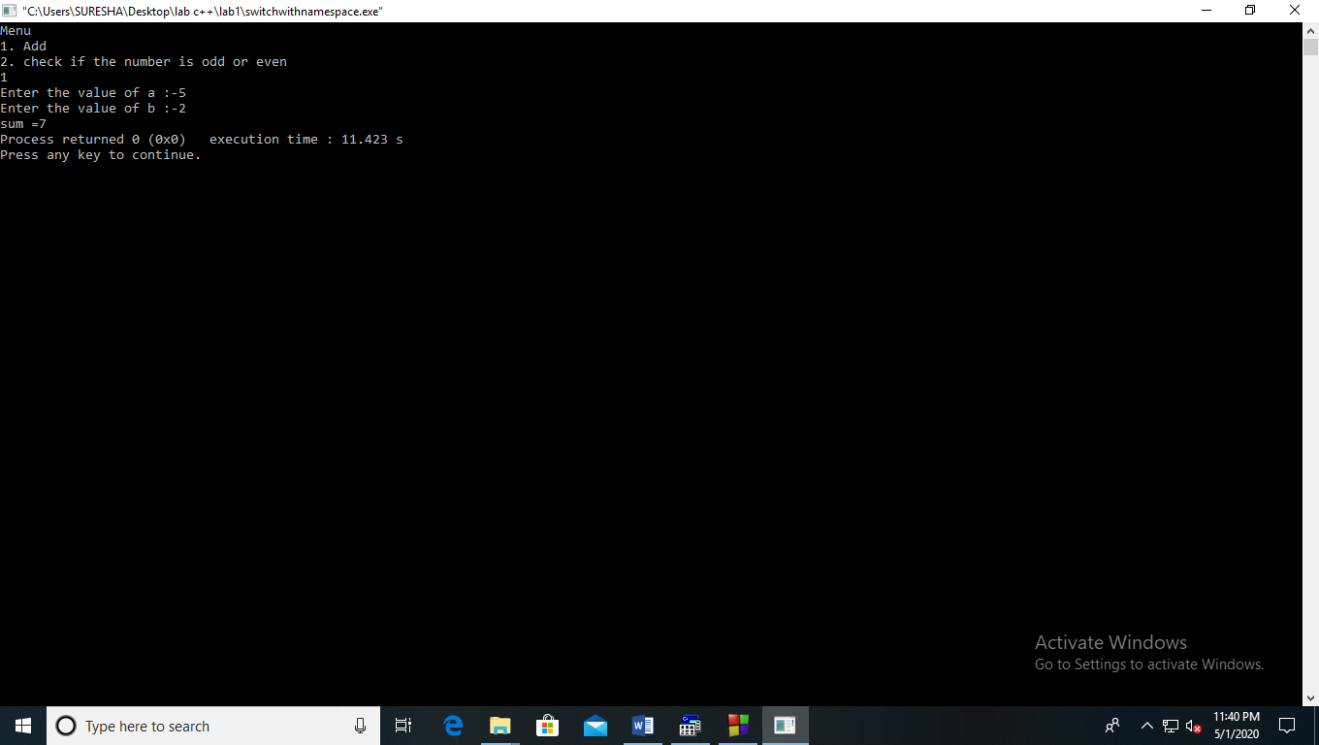

**PRACTICAL NO 2**

Write a program to find whether a number is even or odd

Code:-

#include<iostream.h>

#include<conio.h>

void main()

{

clrscr();

int a;

cout<<"Enter the a number:";

cin>>a;

if(a%2==0)

cout<<"The number is even"<<endl;

else

cout<<"The number is odd"<<endl;

getch();

}

Output:-

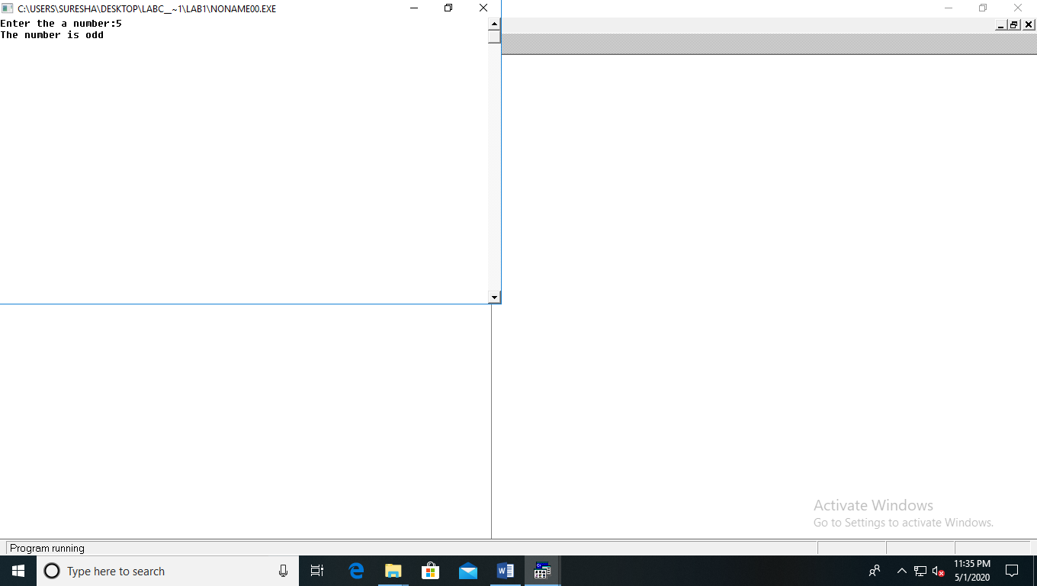

**PRACTICAL NO 3**

Write a program to find whether a number is even or odd and addition of two numbers using switch case

Code:-

#include<iostream>

#include<conio.h>

int sum(int a,int b)

{

int c=a+b;

return c;

}

int check(int a)

{

return a%2;

}

int main()

{

Clrscr();

int a,b,c,ch;

cout<<"Menu"<<endl<<"1. Add "<<endl<<"2. check if the number is odd or even"<<endl;

cin>>ch;

switch(ch)

{

case 1:

cout<<"Enter the value of a :-";

cin>>a;

cout<<"Enter the value of b :-";

cin>>b;

c=sum(a,b);

cout<<"sum ="<<c;

break;

case 2:

cout<<"Enter the value :- ";

cin>>a;

c=check(a);

if(c==0)

cout<<a<<" is even";

else

cout<<a<<" is odd";

break;

default:

cout<<"Wrong choice !!!!";

}

return 0;

getch();

}

Output:-

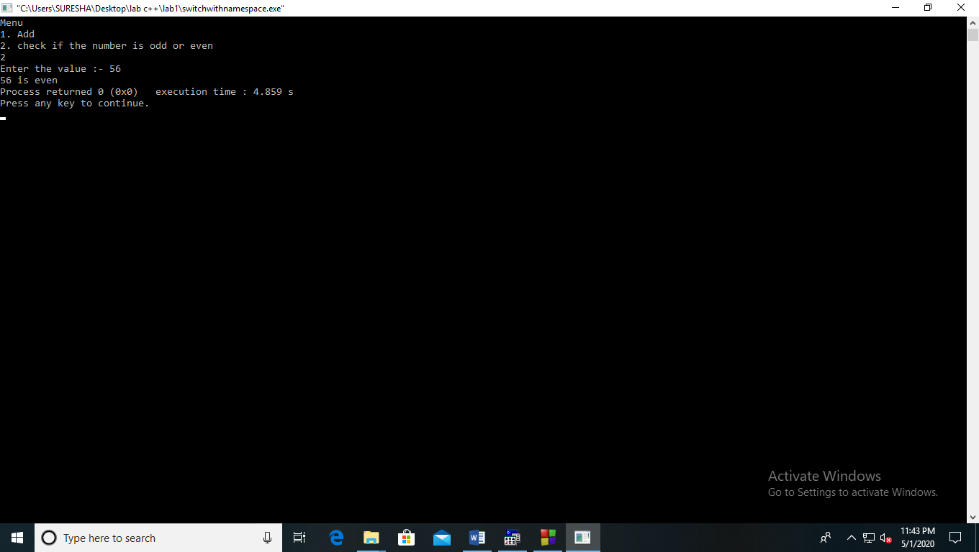

**PRACTICAL NO 4**

Write a program to find whether a number is even or odd and addition of two numbers using switch case using characters

Code:-

#include<iostream.h>

#include<conio.h>

int sum(int a,int b)

{

int c=a+b;

return c;

}

int check(int a)

{

return a%2;

}

void main()

{

clrscr();

int a,b,c;

char ch;

cout<<"Menu"<<endl<<"a. Add "<<endl<<"b. check if the number is odd or even"<<endl;

cin>>ch;

switch(ch)

{

case 'a':

cout<<"Enter the value of a :-";

cin>>a;

cout<<"Enter the value of b :-";

cin>>b;

c=sum(a,b);

cout<<"sum ="<<c;

break;

case 'b':

cout<<"Enter the value :- ";

cin>>a;

c=check(a);

if(c==0)

cout<<a<<" is even";

else

cout<<a<<" is odd";

break;

default:

cout<<"Wrong choice !!!!";

}

getch();

}

Output:- 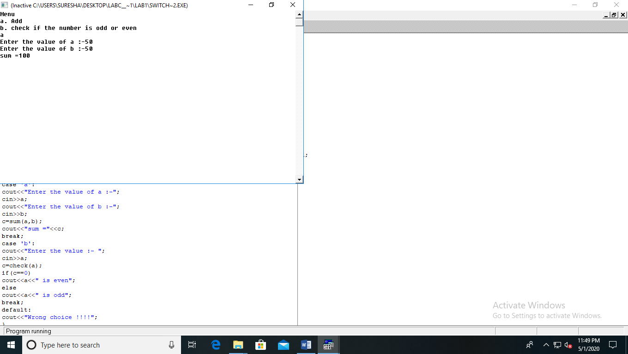

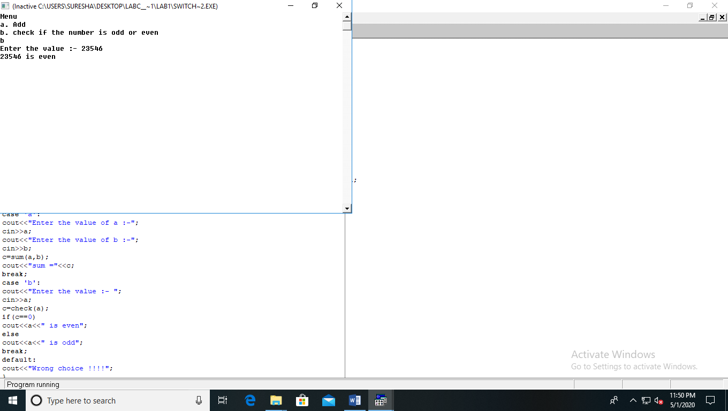

**PRACTICAL NO 5**

Write a program to implement following pattern:

1

22

333

4444

Code:-

#include<iostream.h>

#include<conio.h>

#include<stdio.h>

void main()

{

clrscr();

int i,j,n;

cout<<"Enter the rows:";

cin>>n;

for(i=1;i<=n;i++)

{

for(j=1;j<=i;j++)

{

cout<<i;

}

cout<<"\n";

}

getch();

}

Output:-

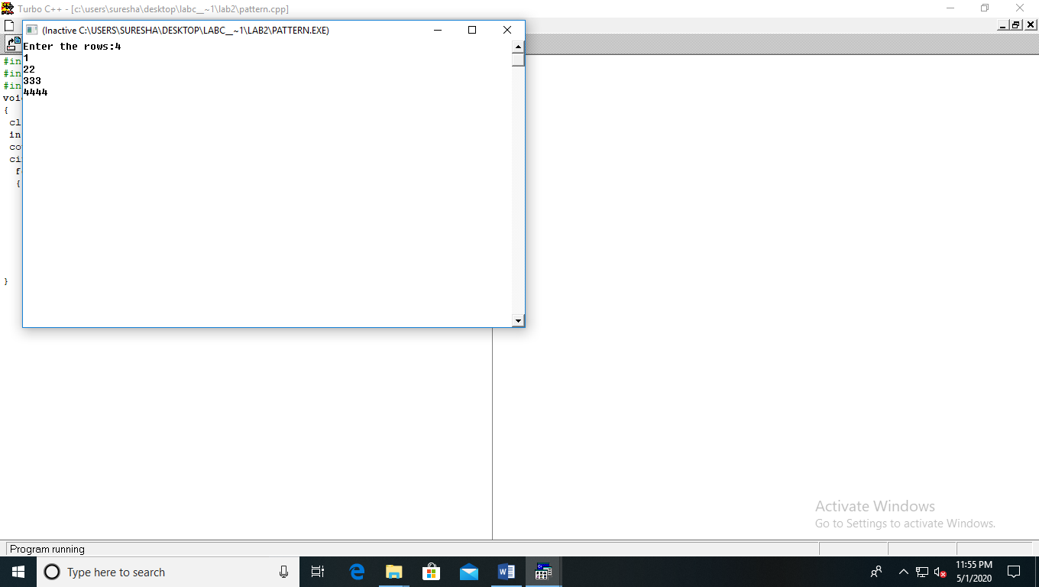

**PRACTICAL NO 6**

Write a program to swap two function using call by value

Code:-

#include<iostream.h>

#include<stdio.h>

#include<conio.h>

void swap(int,int);

int main()

{

clrscr();

int num1,num2;

cout<<"\n Enter First Number : ";

cin>>num1;

cout<<"\n Enter Second Number : ";

cin>>num2;

cout<<"\n Before Swapping the Value : \n"<<" "<<num1<<"\t"<<num2<<"\n";

swap(num1,num2);

cout<<"\n Outside Function After Swapping the Value : \n"<<" "<<num1<<"\t"<<num2<<"\n";

getch();

return 0;

}

void swap(int num1,int num2)

{

int num3;

num3=num1;

num1=num2;

num2=num3;

cout<<"\n Inside Function After Swapping the Value : \n"<<" "<<num1<<"\t"<<num2;

}

Output:-  
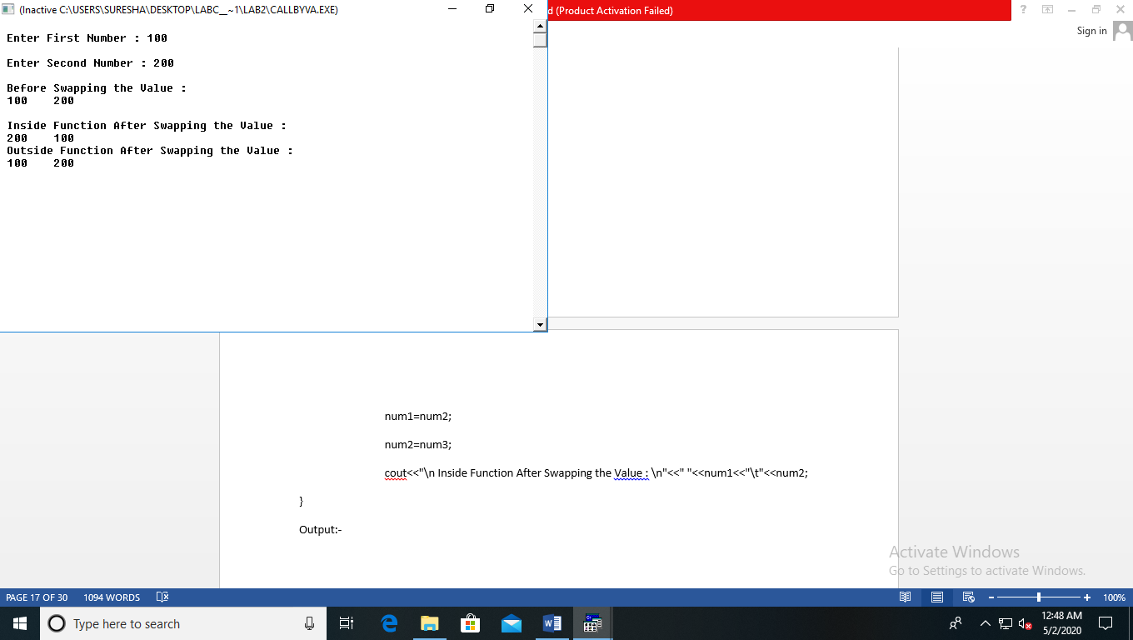

**PRACTICAL NO 7**

Write a program to swap two function using call by address

Code:-

#include<iostream.h>

#include<conio.h>

#include<stdio.h>

void swap(int *a, int *b)

{

int z;

z = *a;

*a = *b;

*b = z;

}

int main()

{

int a = 50, b = 100;

cout<<"Before :"<<a<<","<<b<<endl;

swap(&a,&b);

cout<<"After :"<<a<<","<<b;

getch();

return 0;

}

Output:-

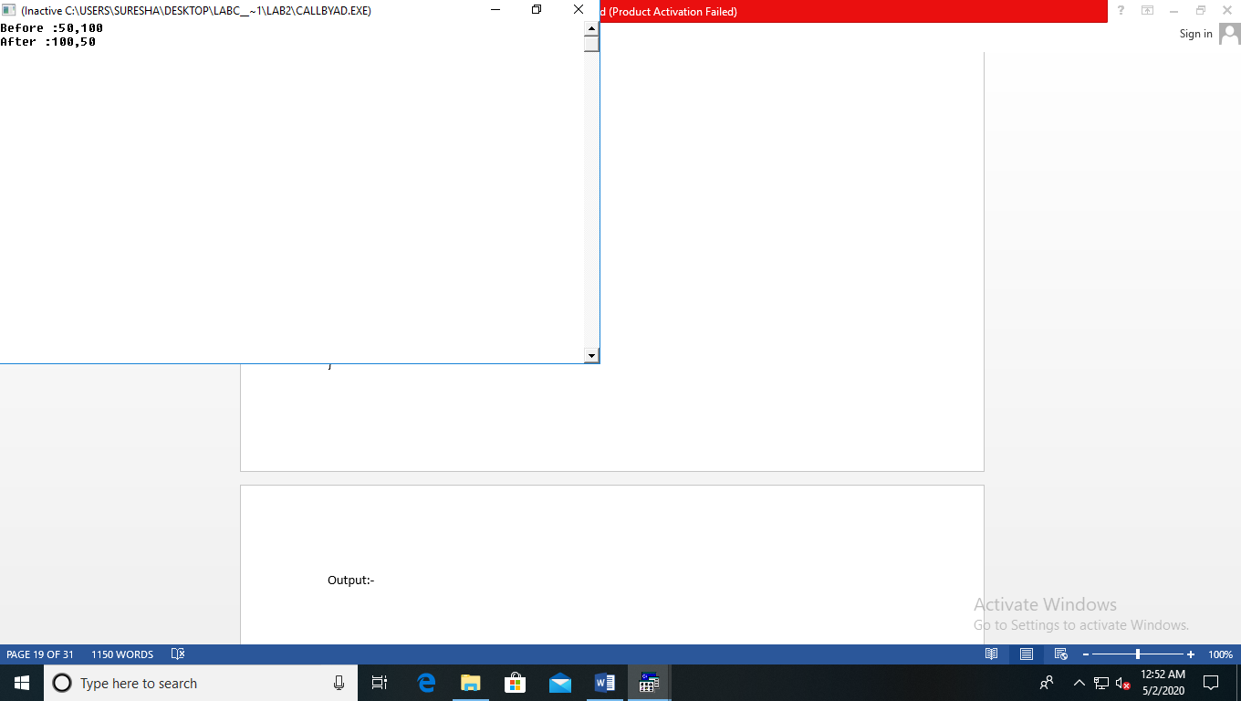

**PRACTICAL NO 8**

Write a program to swap two function using call by reference

Code:-

#include<iostream.h>

#include<conio.h>

#include<stdio.h>

void swap(int&, int&);

int main()

{

clrscr();

int a = 10,b = 20;

cout<<"BEFORE SWAPPING"<< endl;

cout<<"a= "<< a << endl;

cout<<"b= "<< b << endl;

swap(a,b);

cout<<"\nAFTER SWAPPING"<< endl;

cout<<"a= "<< a << endl;

cout<<"b= "<< b << endl;

getch();

return 0;

}

void swap(int& n1,int& n2)

{

int temp;

temp = n1;

n1 = n2;

n2 = temp;

}

Output:-

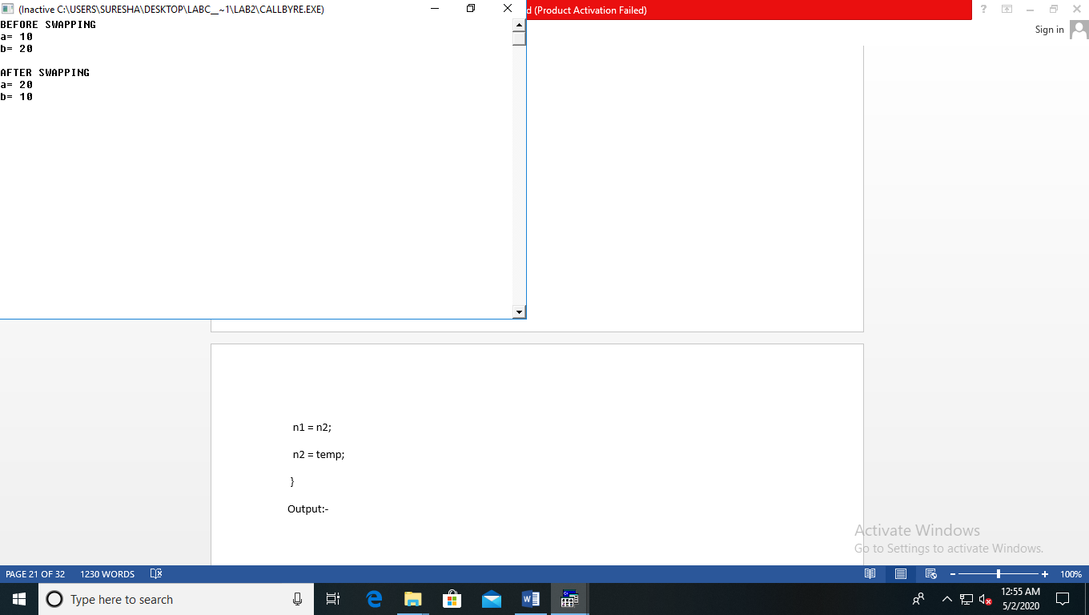

**PRACTICAL NO 9**

Write a program to sort string passed by commandline

Code:-

#include<iostream.h>

#include<conio.h>

#include<stdlib.h>

#include<string.h>

#include<stdio.h>

void main(int argc,char *argv[])

{

int i,b[10];

char a[10][10],*temp;

clrscr();

for(i=1;i<argc;i++)

strcpy(a[i],argv[i]);

for(i=1;i<argc;i++)

b[i]=strlen(a[i]);

for( i=1;i<argc-1;i++)

{

for(int j=1;j<argc;j++)

if(b[i]<b[j])

{

strcpy(temp,a[j]);

strcpy(a[j],a[i]);

strcpy(a[i],temp);

}

}

for(i=1;i<argc;i++)

{

puts(a[i]);

cout<<endl;

}

getch();

}

Output:-

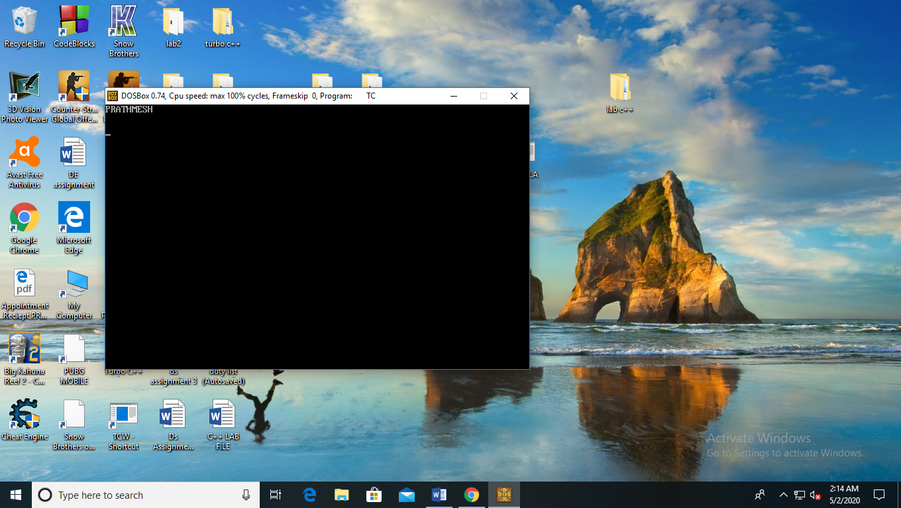

**PRACTICAL NO 10**

WAP a program to maintain the student record containing roll number , Name, marks1, marks2, marks3 as data member and getdata(), display() and setdata() as member functions(use array of object)

Code :-

#include<iostream.h>

#include<conio.h>

#include<stdio.h>

class student

{

private:

int roll;

int physics,maths,sum;

char name[25];

public:

void readval();

void display();

void caltotal();

};

void student::readval()

{

cout<<"enter the roll no :- ";

cin>>roll;

cout<<"enter the name :-";

gets(name);

cout<<" enter the marks of physics:-";

cin>>physics;

cout<<" enter the marks of maths :-";

cin>>maths;

}

void student::display()

{

cout<<endl<<"name :-";

puts(name);

cout<<"roll no :- "<<roll<<endl;

cout<<"physics marks:-"<<physics<<endl;

cout<<"maths marks:-"<<maths<<endl;

}

void student::caltotal()

{

sum=physics+maths;

cout<<"total ="<<sum<<endl<<endl;

}

void main()

{

clrscr();

int n;

student s[10];

cout<<"enter the number of details you want :-";

cin>>n;

for(int i=0;i<n;i++)

{

s[i].readval();

s[i].display();

s[i].caltotal();

}

getch();

}

Output :-

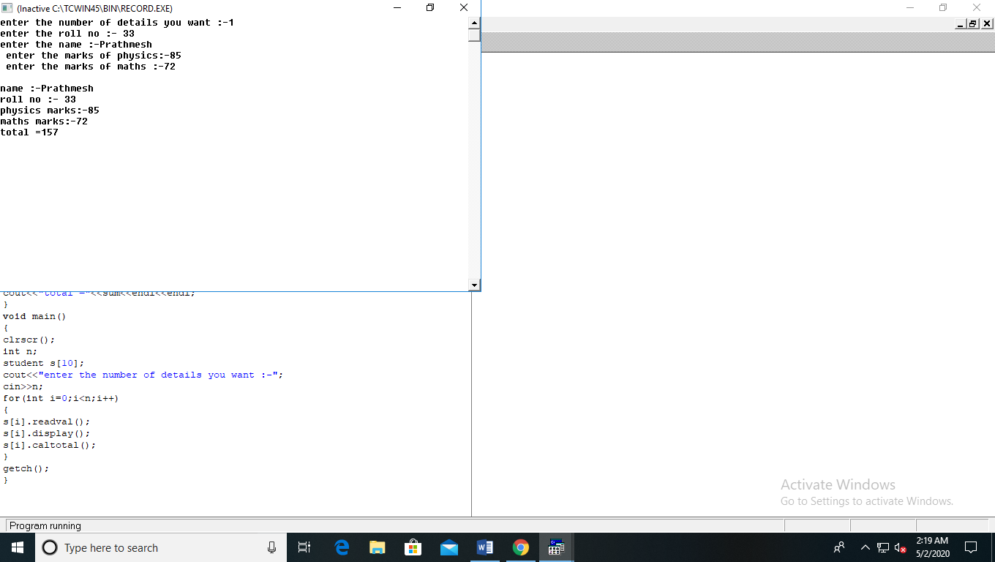

**PRACTICAL NO 11**

Write a class bank, containing data member: Name of Depositor, A/c type, Type of A/c, Balance amount. Member function: To assign initial value, To deposit an amount, to withdraw an amount after checking the balance (which should be greater than Rs. 500) ,To display name & balance

Code :-

#include<iostream.h>

#include<conio.h>

#include<stdio.h>

class bank

{

private:

int acc_no;

float balance;

char name[25];

public:

void get_details();

void deposit();

void withdraw();

void display();

};

void bank::get_details()

{

cout<<"Enter the name of the user :-";

gets(name);

cout<<"\n Enter the account number of user :-";

cin>>acc_no;

cout<<"\n Enter the balance of the account :-";

cin>>balance;

}

void bank::withdraw()

{

int draw;

cout<<"Enter the money to be withdraw:-";

cin>>draw;

if(balance<draw)

cout<<"not sufficient balance";

else

{

balance=balance-draw;

cout<<"the remaining balance ="<<balance;

}

}

void bank::deposit()

{

int des;

cout<<"Enter the money to be deposit:-";

cin>>des;

balance=balance+des;

cout<<"updated balance ="<<balance;

}

void bank::display()

{

cout<<"Name of the user :-";

puts(name);

cout<<"\n Account number of user "<<acc_no<<endl;

cout<<"\n Balance of the account :-"<<balance<<endl;

}

void main()

{

clrscr();

int ch;

char opt='y';

bank p1;

while(opt=='y'||opt=='Y')

{

cout<<”=================\n Menu \n 1. Create account \n 2. Deposit money \n 3.Withdraw money \n 4. Display details \n =================\n Enter your choice:-";

cin>>ch;

switch(ch)

{

case 1:

p1.get_details();

cout<<"\n Do you want to continue (y or n)";

cin>>opt;

break;

case 2:

p1.deposit();

cout<<"\n Do you want to continue (y or n)";

cin>>opt;

break;

case 3:

p1.withdraw();

cout<<"\n Do you want to continue (y or n)";

cin>>opt;

break;

case 4:

p1.display();

cout<<"\n Do you want to continue (y or n)";

cin>>opt;

break;

default:

cout<<"wrong choice";

}

}

getch();

}

Output :-

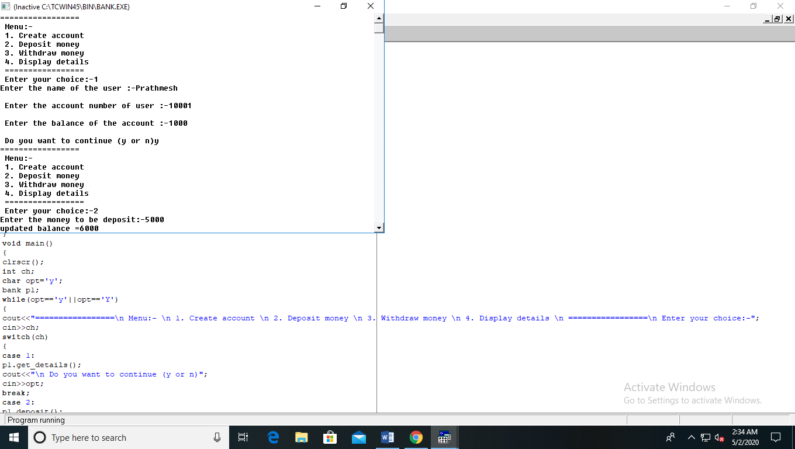

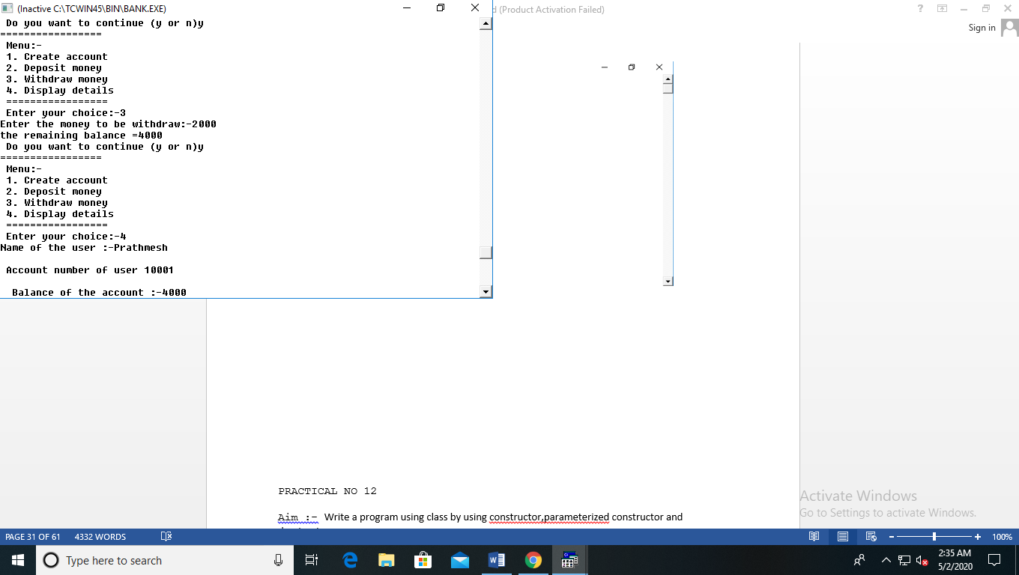

**PRACTICAL NO 12**

Write a program using class by using constructor,parameterized constructor and desctructor

Code :-

#include<iostream.h>

#include<conio.h>

class ONE

{

private :

int num;

public:

ONE()

{

num=10;

cout<<"\ndefault constructor"<<endl;

cout<<"Num ="<<num;

}

ONE(int a)

{

num=a;

cout<<"\nparameterized contructor"<<endl;

cout<<"Num="<<num;

}

~ONE()

{

cout<<"\ndestructor";

}

};

void main()

{

clrscr();

ONE obj1;

ONE obj2(20);

getch();

}

Output :-

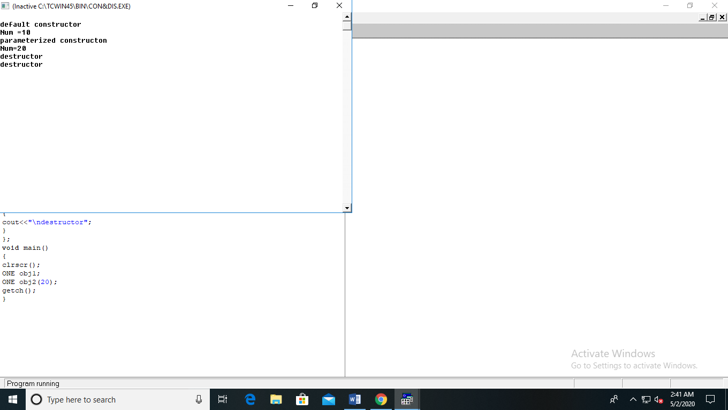

**PRACTICAL NO 13**

Write a program to swap the data of two objects of two class by using friend function

Code :-

#include<iostream.h>

#include<conio.h>

class ONE;

class TWO

{

private :

int num2;

public:

friend void swap(ONE,TWO);

}obj;

class ONE

{

private:

int num1;

public:

friend void swap(ONE,TWO);

}obj1;

void swap(ONE obj1,TWO obj)

{

cout<<"Enter the value of ONE :-";

cin>>obj1.num1;

cout<<"Enter the value of TWO :-";

cin>>obj.num2;

int temp;

temp=obj.num2;

obj.num2=obj1.num1;

obj1.num1=temp;

cout<<"after swap "<<endl<<"value of ONE :- "<<obj1.num1<<endl<<"value of TWO :- "<<obj.num2;

}

void main()

{

clrscr();

swap(obj1,obj);

getch();

}

Output :-

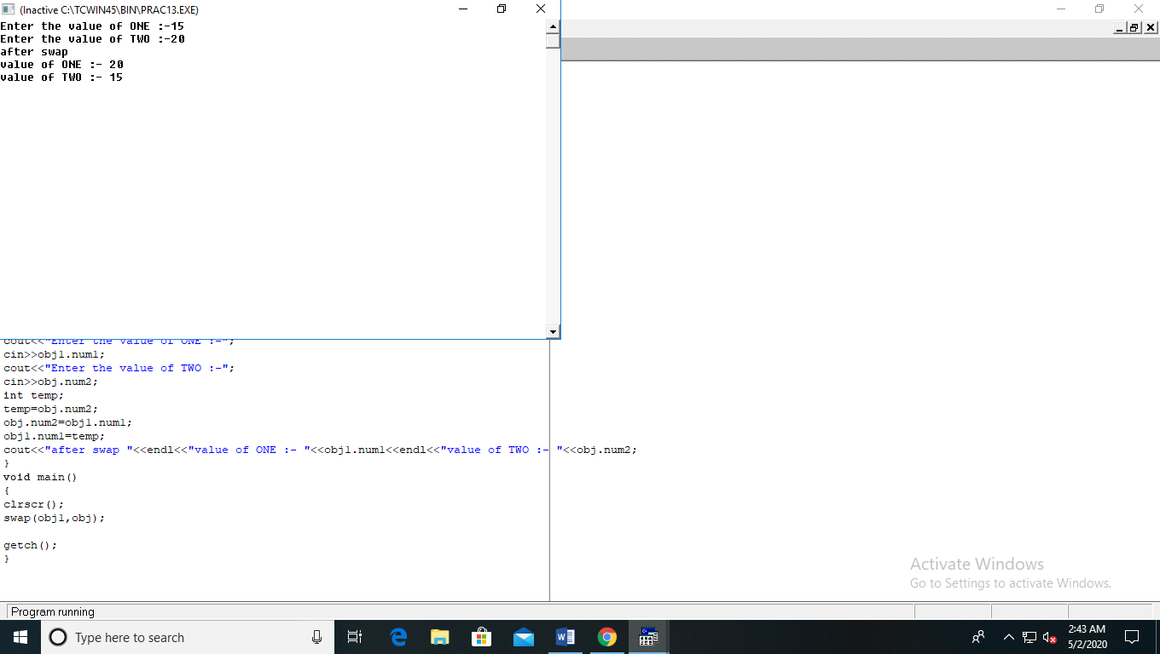

**PRACTICAL NO 14**

Write a program to swap two object data by using

Pointer object.

Code :-

#include<iostream.h>

#include<conio.h>

class ONE;

class TWO

{

private :

int num2;

public:

friend void swap(ONE *obj1,TWO *obj);

}obj;

class ONE

{

private:

int num1;

public:

friend void swap(ONE *obj1,TWO *obj);

}obj1;

void swap(ONE *obj1,TWO *obj)

{

cout<<"Enter the value of ONE :-";

cin>>obj1->num1;

cout<<"Enter the value of TWO :-";

cin>>obj->num2;

int temp;

temp=obj->num2;

obj->num2=obj1->num1;

obj1->num1=temp;

cout<<"after swap "<<endl<<"value of ONE = "<<obj1->num1<<endl<<"value of TWO = "<<obj->num2;

}

void main()

{

clrscr();

swap(&obj1,&obj);

getch();

}

Output :-

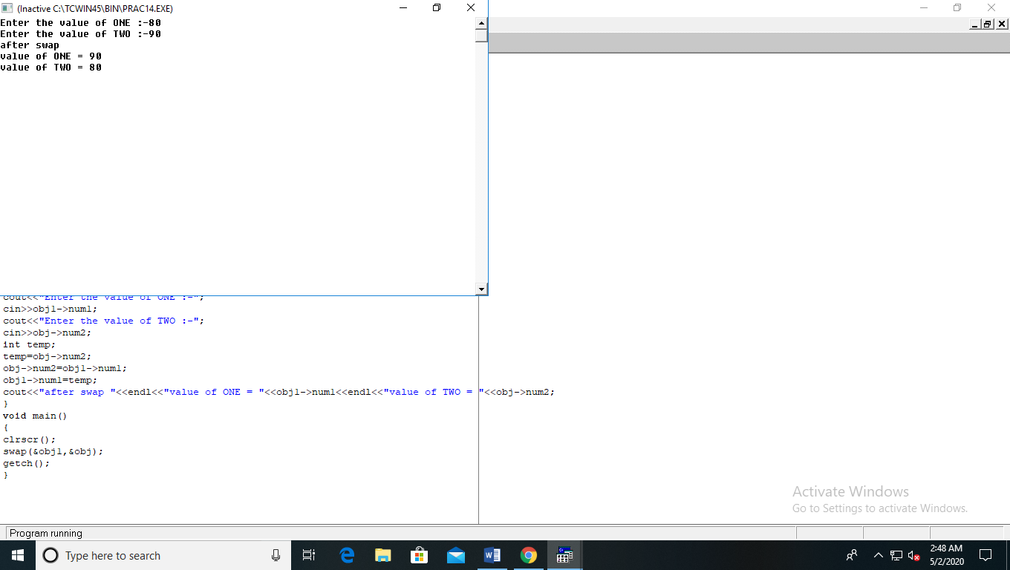

**PRACTICAL NO 15**

Write a program to swap the data of two objects of the same class using friend function

Code :-

#include<iostream.h>

#include<conio.h>

class ONE;

class TWO

{

private :

int num2;

public:

void swap(ONE);

}obj;

class ONE

{

private:

int num1;

public:

friend class TWO;

}obj1;

void TWO::swap(ONE obj1)

{

cout<<"Enter the value of ONE :-";

cin>>obj1.num1;

cout<<"Enter the value of TWO :-";

cin>>num2;

int temp;

temp=num2;

num2=obj1.num1;

obj1.num1=temp;

cout<<"after swap "<<endl<<"value of ONE :- "<<obj1.num1<<endl<<"value of TWO :- "<<num2;

}

void main()

{

clrscr();

obj.swap(obj1);

getch();

}

Output :-

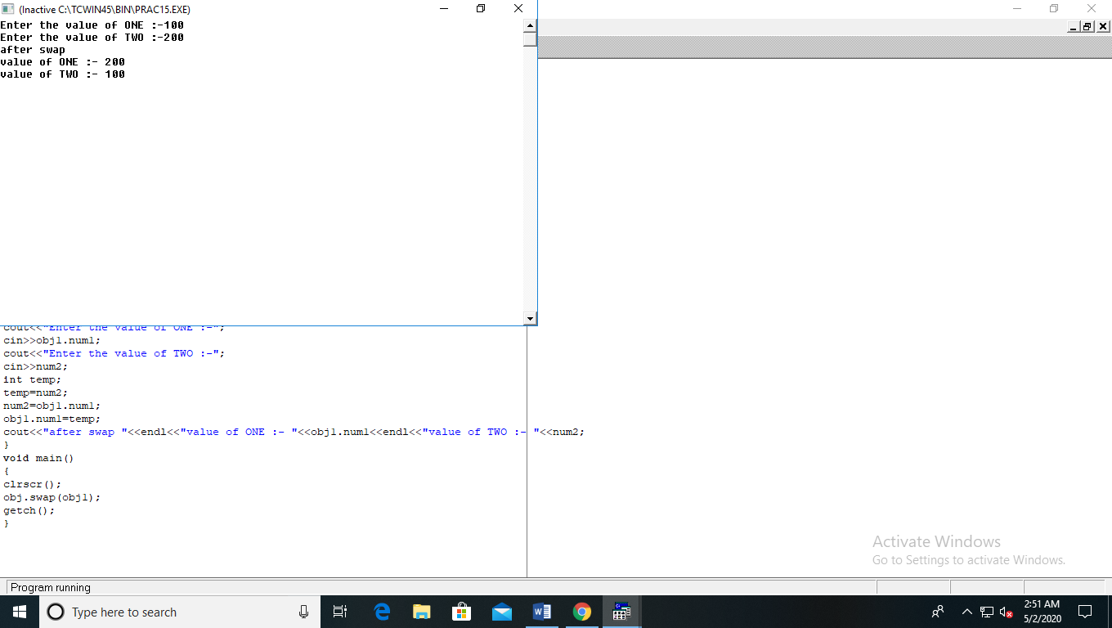

**PRACTICAL NO 16**

Write a program to display content of an class using this pointer.

Code :-

#include<iostream.h>

#include<conio.h>

class ONE

{

private :

int num;

public:

ONE()

{

num=10;

cout<<"default constructor"<<endl;

cout<<"Num ="<<num;

}

ONE(int a)

{

num=a;

this->num;

cout<<endl<<"parameterized contructor"<<endl;

cout<<"Num="<<num<<endl;

cout<<"this :- ";

cout<<this;

}

~ONE()

{

cout<<"destructor";

}

};

void main()

{

clrscr();

ONE obj1;

ONE obj2(20);

getch();

}

Output :-

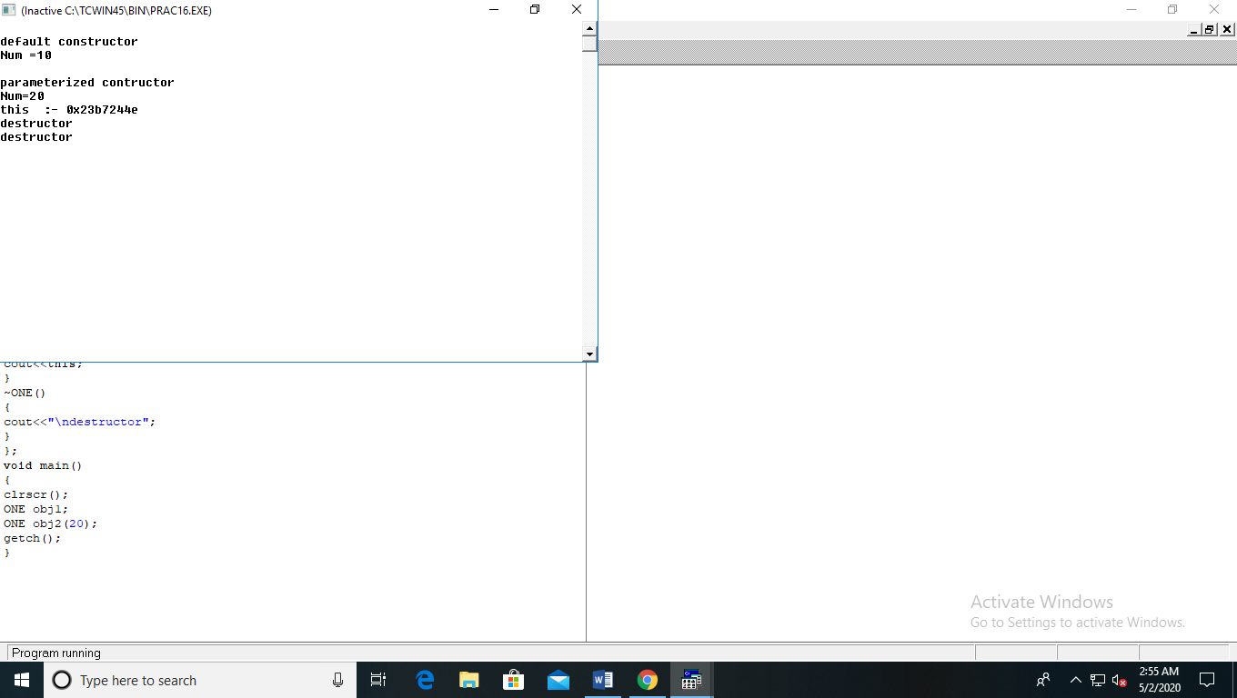

**PRACTICAL NO 17**

Write a program to perform addition of 2 matrix using class

Code :-

#include<iostream.h>

#include<conio.h>

class A

{

private :

int a[3][3];

public :

void getdata();

void display();

void add(A obj1);

};

void A::display()

{

int i,j;

cout<<"Addition of matrix is :-"<<endl;

for(i=0;i<3;i++)

{

for(j=0;j<3;j++)

{

cout<<" "<<a[i][j]<<" ";

}

cout<<endl;

}

}

void A::getdata()

{

int i,j;

for(i=0;i<3;i++)

{

for(j=0;j<3;j++)

cin>>a[i][j];

}

}

void A::add(A obj1)

{

int i,j;

for(i=0;i<3;i++)

{

for(j=0;j<3;j++)

{

a[i][j]=a[i][j]+obj1.a[i][j];

}

}

}

void main()

{

clrscr();

A obj1,obj;

cout<<"Matrix -1 :- "<<endl;

obj.getdata();

cout<<"Matrix 2 :- "<<endl;

obj1.getdata();

obj.add(obj1);

obj.display();

getch();

}

Output :-

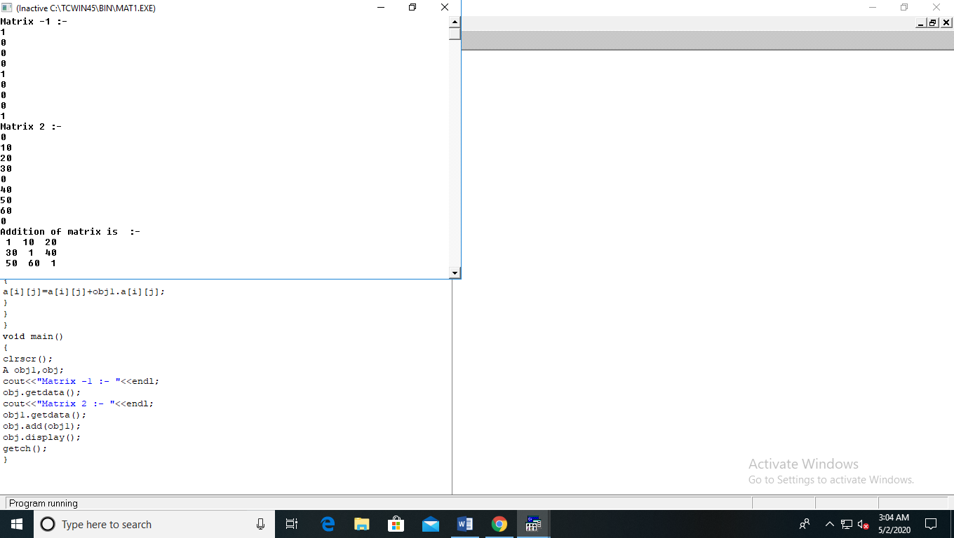

**PRACTICAL NO 18**

Write a program to perform subtraction of 2 matrix using class

Code :-

#include<iostream.h>

#include<conio.h>

class A

{

private :

int a[3][3];

public :

void getdata();

void display();

void sub(A obj1);

};

void A::display()

{

int i,j;

cout<<"Subtraction of matrix is :-"<<endl;

for(i=0;i<3;i++)

{

for(j=0;j<3;j++)

{

cout<<" "<<a[i][j]<<" ";

}

cout<<endl;

}

}

void A::getdata()

{

int i,j;

for(i=0;i<3;i++)

{

for(j=0;j<3;j++)

cin>>a[i][j];

}

}

void A::sub(A obj1)

{

int i,j;

for(i=0;i<3;i++)

{

for(j=0;j<3;j++)

{

a[i][j]=a[i][j]-obj1.a[i][j];

}

}

}

void main()

{

clrscr();

A obj1,obj;

cout<<"Matrix -1 :- "<<endl;

obj.getdata();

cout<<"Matrix 2 :- "<<endl;

obj1.getdata();

obj.sub(obj1);

obj.display();

getch();

}

Output :-

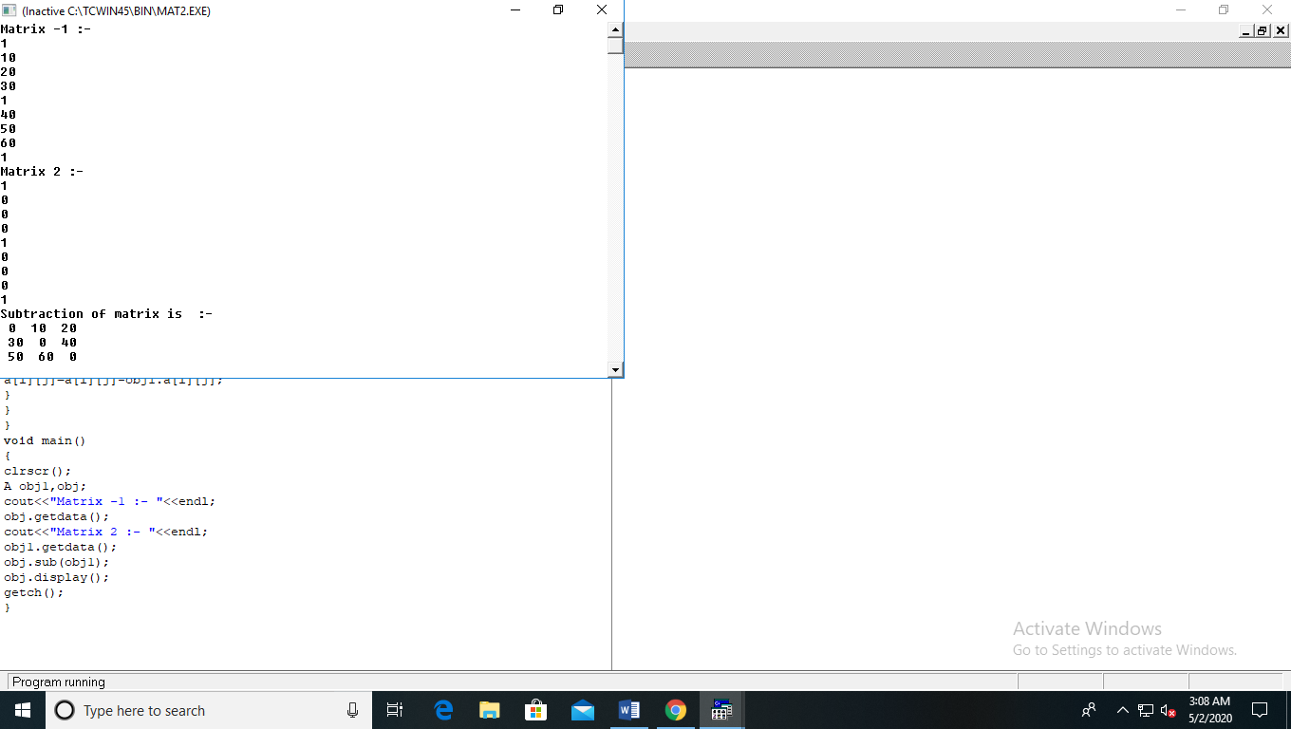

**PRACTICAL NO 19**

Write a program to perform transpose of matrix using class

Code :-

#include<iostream.h>

#include<conio.h>

class A

{

private :

int a[3][3];

public :

void getdata();

void display();

void transpose();

};

void A::display()

{

int i,j;

cout<<"Tranpose of matrix is :-"<<endl;

for(i=0;i<3;i++)

{

for(j=0;j<3;j++)

{

cout<<" "<<a[i][j]<<" ";

}

cout<<endl;

}

}

void A::getdata()

{

int i,j;

for(i=0;i<3;i++)

{

for(j=0;j<3;j++)

cin>>a[i][j];

}

}

void A::transpose()

{

int temp,i,j;

for(i=0;i<3-1;i++)

{

for(j=0;j<3;j++)

{

if(i < j)

{

temp=a[i][j];

a[i][j]=a[j][i];

a[j][i]=temp;

}

else

{

;

}

}

}

}

void main()

{

clrscr();

A obj;

cout<<"Matrix :- "<<endl;

obj.getdata();

obj.transpose();

obj.display();

getch();

}

Output:-

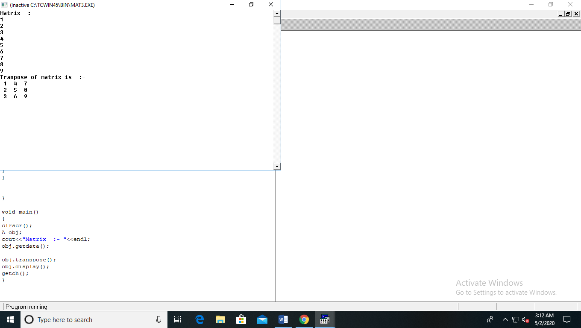

**PRACTICAL NO 20**

Write a program to using enumernation for month having 28 , 30 and 31 days in a month.

Code :-

#include<iostream.h>

#include<string.h>

enum month{jan=1,feb,march,april,may,june,july,aug,september,october,november,december};

int main()

{

int selection;

char ch[12][10]={"jan","feb","march","april","may","june","july","august","september","october","november","december"};

cout<<"Select the month that you want to enter(1-12):- ";

cin>>selection;

switch(selection)

{

case jan:

case march:

case may:

case july:

case aug:

case october:

case december:

cout<<"this ";

// puts(ch[selection-1]);

cout<<" have 31 days "<<endl;

break;

case april:

case june:

case september:

case november:

cout<<"this ";

//puts(ch[selection-1]);

cout<<" have 30 days "<<endl;

break;

case feb:

cout<<"this ";

// puts(ch[selection-1]);

cout<<" have 29 days "<<endl;

break;

default :

cout<<"wrong choice";

}

return 0;

}

Output :-

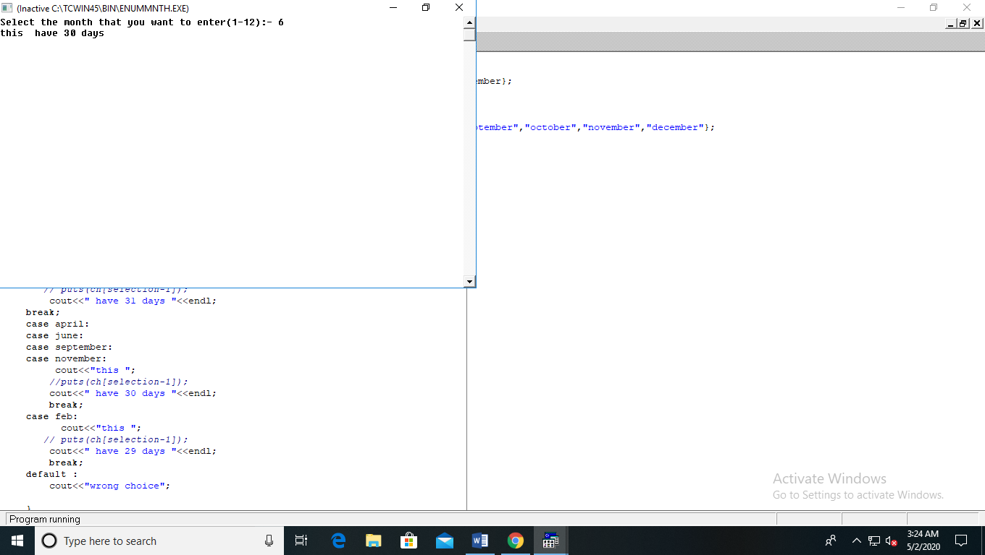

**PRACTICAL NO 21**

Write a program to create header file including swap functions and addition function for integer,float and char

Code :-

#include<iostream>

using namespace std;

void swap(int &a,int &b)

{

int c;

c=a;

a=b;

b=c;

}

float swap(float &a,float &b)

{

float c;

c=a;

a=b;

b=c;

}

float swap(char &a,char &b)

{

char c;

c=a;

a=b;

b=c;

}

int add(int a,int b)

{

int c;

c=a+b;

return c;

}

float add(float a,float b)

{

float c;

c=a+b;

return c;

}

int main()

{

int a,b,c;

float x,y,z;

int ch,opt=1;

while(opt==1)

{

cout<<"====================\n Menu: \n 1. Addition of integer \n 2. Addition of float \n 3.Swap of int \n 4.Swap of float \n 5. Swap of char \n 6.Exit \n ====================\n Enter your choice :-";

cin>>ch;

switch(ch)

{

case 1:

cout<<"enter interger 1 :-";

cin>>a;

cout<<"enter interger 2 :-";

cin>>b;

c=add(a,b);

cout<<"Addition of 2 integer is :-"<<c<<endl;

break;

case 2:

cout<<"enter float 1 :-";

cin>>x;

cout<<"enter float 2 :-";

cin>>y;

z=add(x,y);

cout<<"Addition of 2 float is :-"<<z<<"\n"<<endl;

break;

case 3:

char u,v;

cout<<"enter interger 1 :-";

cin>>a;

cout<<"enter interger 2 :-";

cin>>b;

swap(a,b);

cout<<"after swapping :-"<<a<<"\n"<<b<<endl;

break;

case 4:

cout<<"enter float 1 :-";

cin>>x;

cout<<"enter float 2 :-";

cin>>y;

swap(x,y);

cout<<"after swapping :-"<<x<<"\n"<<y<<endl;

break;

case 5:

cout<<"enter character 1 :-";

cin>>u;

cout<<"enter character 2 :-";

cin>>v;

swap(u,v);

cout<<"after swapping :-"<<u<<"\n"<<v<<endl;

break;

case 6:

cout<<"ALL OPERATIONS ARE DONE"<<endl;

default:

cout<<"wrong choice !!";

break;

}

}

return 0;

}

Output:-

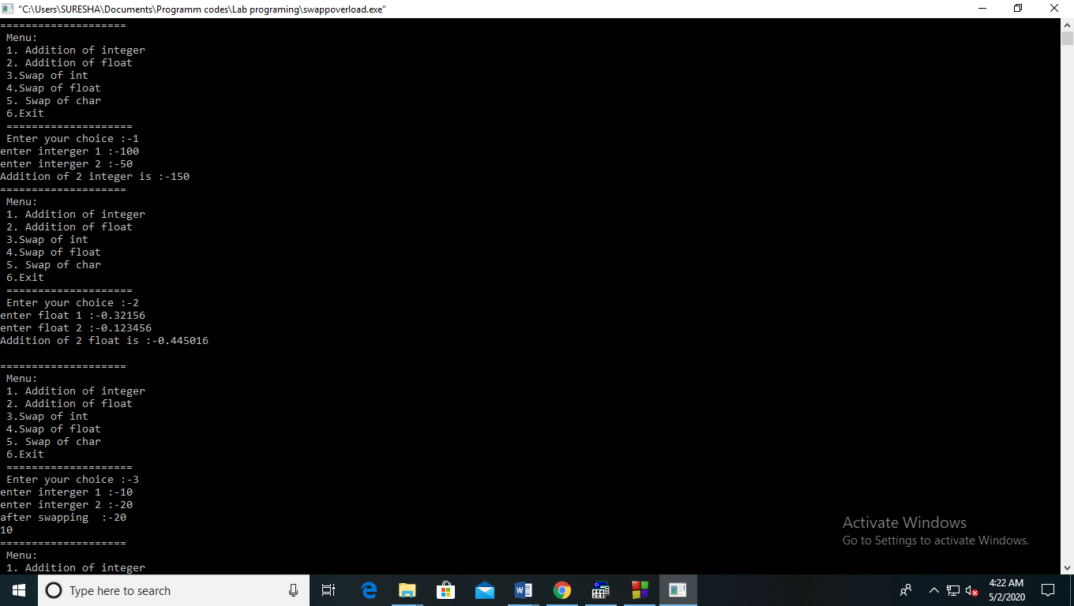

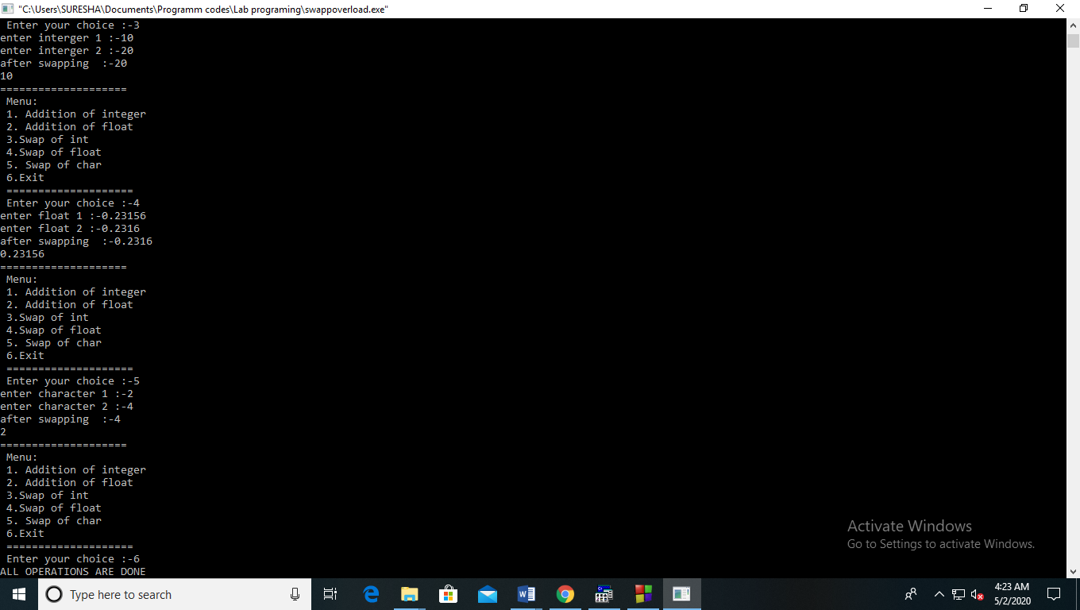

**PRACTICAL NO 22**

Write a program to swap two integer , two float and two character

Code :-

#include<iostream>

using namespace std;

void swap(int &a, int &b)

{

int c;

c=a;

a=b;

b=c;

}

float swap(float &x, float &y)

{

float c;

c=x;

x=y;

y=c;

}

float swap(char &u, char &v)

{

char c;

c=u;

u=v;

v=c;

}

int main()

{

int a,b;

float x,y;

char u,v;

cout<<"Enter the number of integer 1:-";

cin>>a;

cout<<"Enter the number of integer 2:-";

cin>>b;

swap(a,b);

cout<<"After swapping of two integers:-\n"<<a<<"\n"<<b<<endl;

cout<<"Enter the number of float 1:-";

cin>>x;

cout<<"Enter the number of float 2:-";

cin>>y;

swap(x,y);

cout<<"After swapping of 2 floats are:-\n"<<x<<"\n"<<y<<endl;

cout<<"Enter the number of character 1:-";

cin>>u;

cout<<"Enter the number of character 2:-";

cin>>v;

swap(u,v);

cout<<"After swapping of 2 characters is:-\n"<<u<<"\n"<<v<<endl;

return 0;

}

Output :-

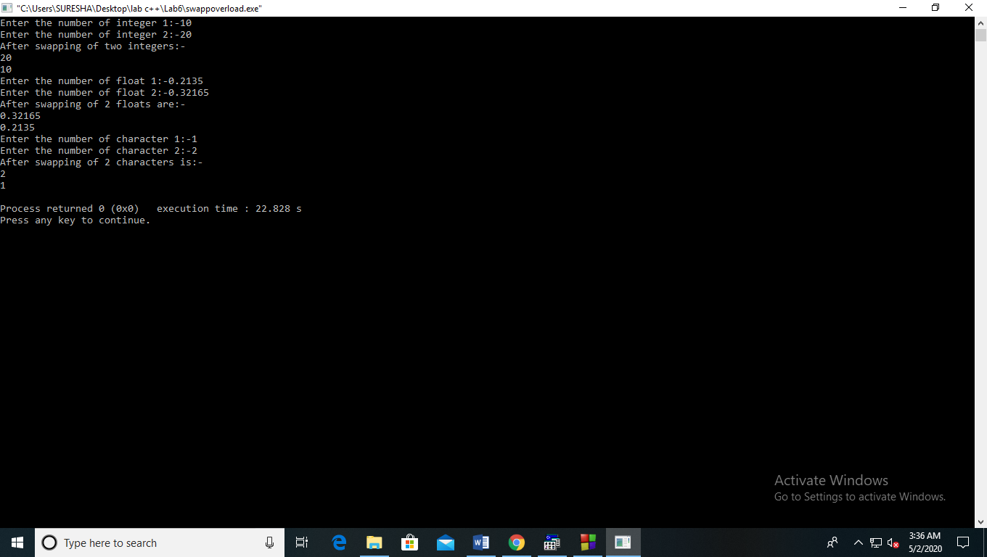

**PRACTICAL NO 23**

Write a program for single inheritance

Code :-

#include<iostream.h>

#include<conio.h>

class A

{

public:

int a;

A()

{

a=0;

}

void getdata1()

{

cout<<"Enter the value of a :- ";

cin>>a;

}

};

class B:public A

{

private :

int b,s;

public:

B()

{

s=0;

}

void getdata2()

{

cout<<"Enter the value of b:- ";

cin>>b;

}

void add()

{

cout<<"\n"<<a;

cout<<"\n" <<b;

cout<<"\n";s=a+b;

cout<<" total ="<<s;

}

};

void main()

{

clrscr();

A obj1;

B obj2;

obj2.getdata1();

obj2.getdata2();

obj2.add();

getch();

}

Output :-

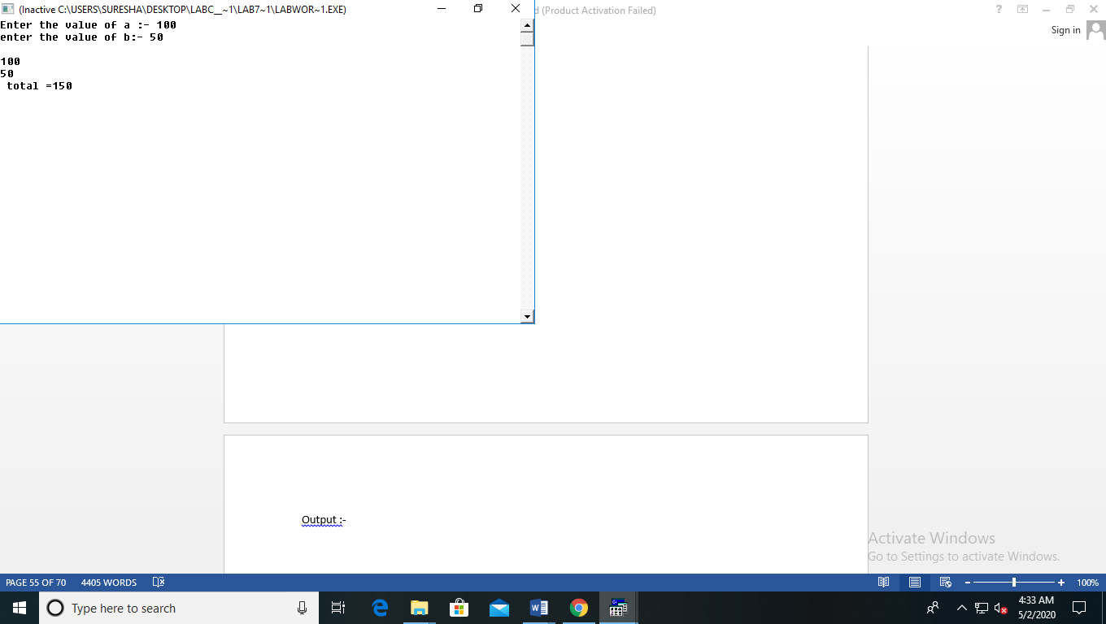

**PRACTICAL NO 24**

Write a program for student and distance student using inheritance

Code :-

#include<iostream.h>

#include<conio.h>

#include<stdio.h>

class student

{

public:

char name[20];

char enrollment_no[12];

char adhar_no[10];

void getdata()

{

cout<<"Enter the name of the student :- ";

gets(name);

cout<<"\n Enter the enrollment number of the student :- ";

gets(enrollment_no);

cout<<"\n Enter the adhar number of the student :- ";

gets(adhar_no);

}

void display()

{

cout<<" Name of the Student :- ";

puts(name);

cout<<"\n Enrollment number of the student :- ";

puts(enrollment_no);

cout<<"\n Adhar Number of the student :- ";

puts(adhar_no);

}

};

class Distancestudent:public student

{

private :

int userid;

char password[12];

public:

void getdata2();

void display2();

};

void Distancestudent::getdata2()

{

cout<<"Enter the user id :- ";

cin>>userid;

cout<<"\n Enter the password :-";

gets(password);

}

void Distancestudent::display2()

{

cout<<" User id :- ";

cout<<userid;

cout<<"\n Password :-";

puts(password);

}

void main()

{

clrscr();

char ch;

int opt;

cout<<"================\n Menu :-\n 1. Create student id \n 2. Create distance student id \n ================\n Enter your choice :-";

cin>>opt;

switch(opt)

{

case 1:

student obj1;

obj1.getdata();

cout<<"The data Entered for student id is :- \n";

obj1.display();

break;

case 2:

Distancestudent obj2;

obj2.getdata();

obj2.getdata2();

cout<<"The data Entered for distance student id is :- \n:-";

obj2.display();

obj2.display2();

break;

default:

cout<<"wrong choice !!";

}

getch();

}

Output :-

1) Student ID

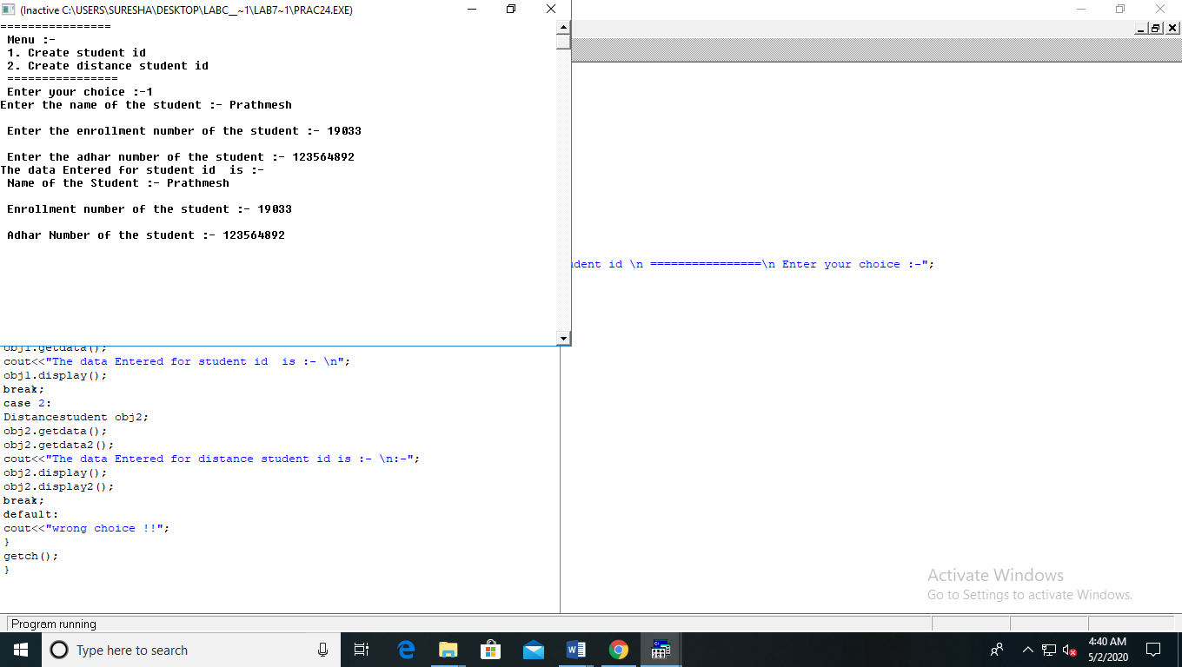

2) Distance student ID

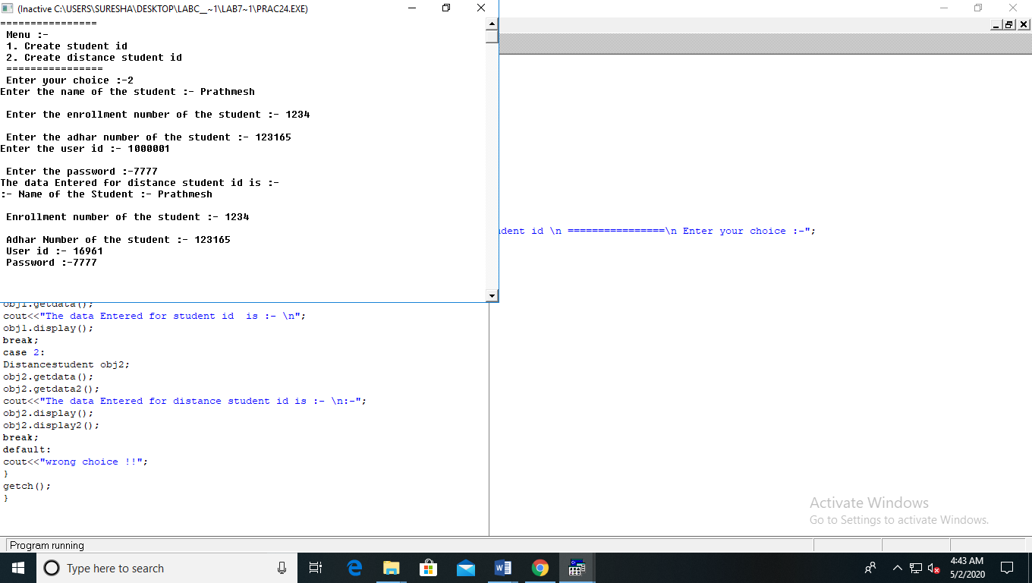

**PRACTICAL NO 25**

create file handling program take input from user as name of the student and two numbers. Write in the file name of the student,  and sum of two numbers.

Code :-

#include<iostream.h>

#include<conio.h>

#include<fstream.h>

void main()

{

clrscr();

ofstream output("student1.txt");

int a,b,c;

char name[20];

cout<<"Enter the name of the student :- ";

cin>>name;

output<<"The name of the student is :-"<<name;

cout<<" \n Enter the two numbers :-";

cin>>a>>b;

c=a+b;

output<<endl<<"The sum of two number is :- "<<c;

cout<<"successfull wrote in file !!";

output.close();

getch();

}

Output :-

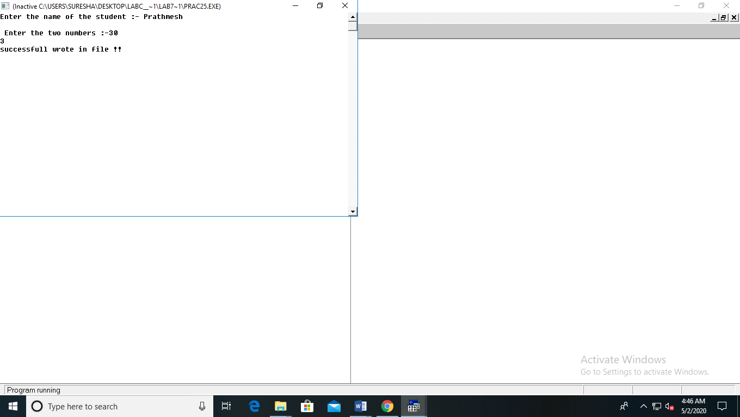

File Output:-

\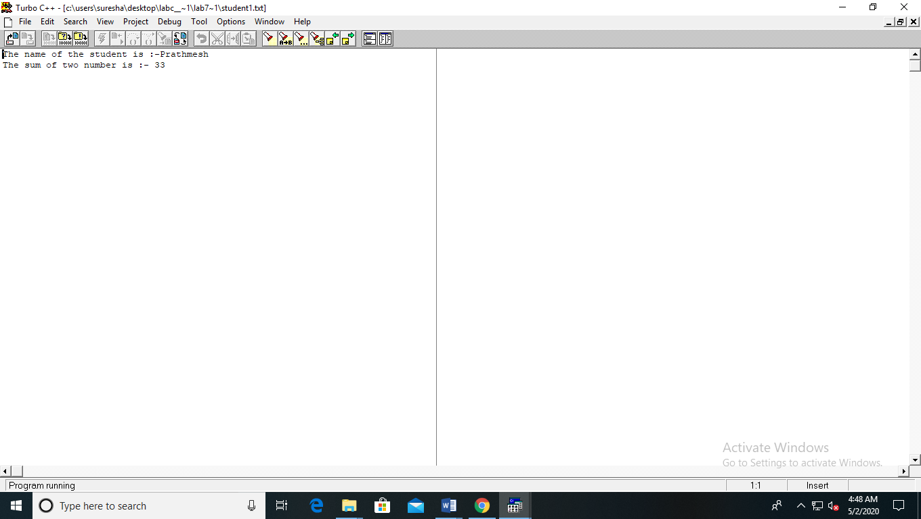

**PRACTICAL NO 26**

Take the input from the user 10 Numbers. if the number is even write in "even.txt" file if the number is odd write in the "odd.txt" file.  Then show the content of both files

Code :-

#include<iostream.h>

#include<fstream.h>

#include<conio.h>

void main()

{

clrscr();

int ar[10],i,j,g=0,h=0;

cout<<"Enter the 10 number :- ";

for(i=0;i<10;i++)

cin>>ar[i];

ofstream f1("even.txt");

ofstream f2("odd.txt");

for(i=0;i<10;i++)

{

if(ar[i]%2==0)

{

f1<<ar[i];

f1<<endl;

h++;

}

else

{

f2<<ar[i];

f2<<endl;

g++;

}

}

f1.close();

f2.close();

ifstream f3("even.txt");

cout<<"even file data :- "<<endl;

for(i=0;i<h;i++)

{

f3>>j;

cout<<j<<endl;

}

f3.close();

ifstream f4("odd.txt");

cout<<"odd file data :- "<<endl;

for(i=0;i<g;i++)

{

f4>>j;

cout<<j<<endl;

}

f4.close();

getch();

}

Output :-

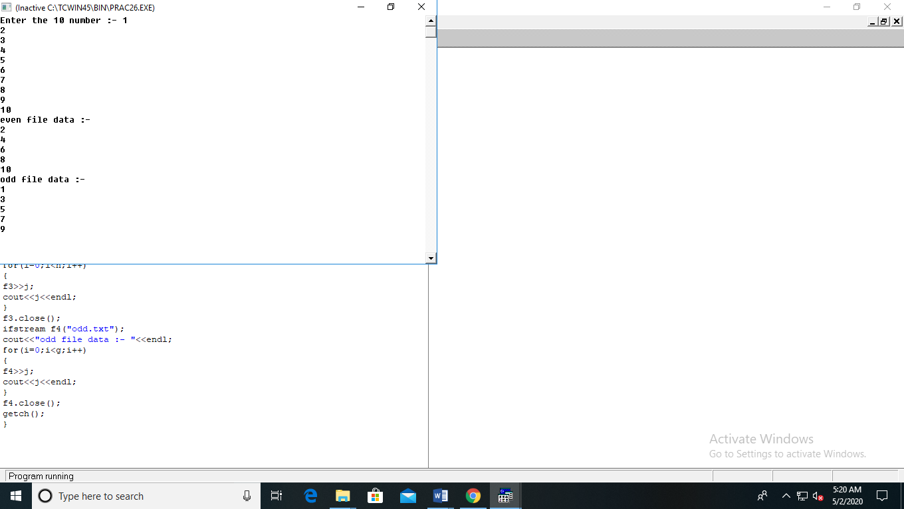

File Output:-

1. Even txt file

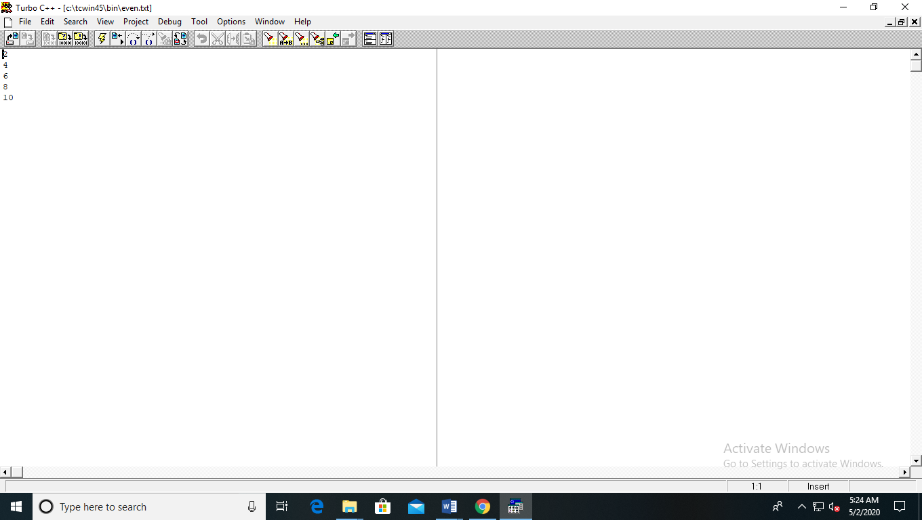

2)Odd txt file:-

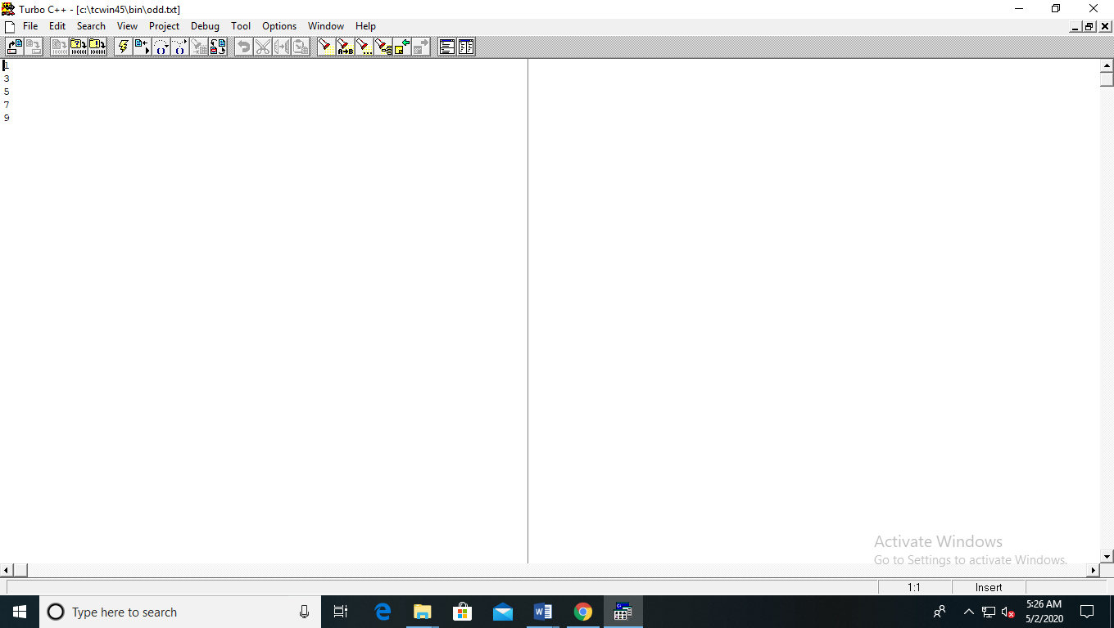

**PRACTICAL NO 27**

Write a program using file handling number of sentences, spaces and number of vowels in the file

Code :-

#include<stdio.h>

#include<iostream.h>

#include<conio.h>

#include<fstream.h>

#include<string.h>

#include<stdlib.h>

void main(int argc, char *argv[])

{

clrscr();

char data[30];

int stmt=0,space=0,vow=0,words=0;

fstream input("data100.txt",ios::in|ios::out);

cout<<"Enter the text :-"<<endl;

gets(data);

int j=strlen(data);

for(i=0;i<=j;i++)

{

input.put(data[i]);

}

input.seekg(0);

cout<<"The text in the file is :- "<<endl;

for(i=0;i<=j;i++)

{

input.get(d);

cout<<d;

words++;

switch(d)

{

case 'A':

case 'E':

case 'I':

case 'O':

case 'U':

case 'a':

case 'e':

case 'i':

case 'o':

case 'u':

vow++;

break;

case '.':stmt++;

break;

case ' ':space++;

break;

case 5:

deafult: words++;

break;

}

}

cout<<endl;

input.close();

cout<<"Total number of line are :- "<<stmt<<endl;

cout<<"Total number of space are :- "<<space<<endl;

cout<<"Total number of vowel are :-"<<vow<<endl;

cout<<"Total number of words are :-"<<words<<endl;

getch();

}

Output :-

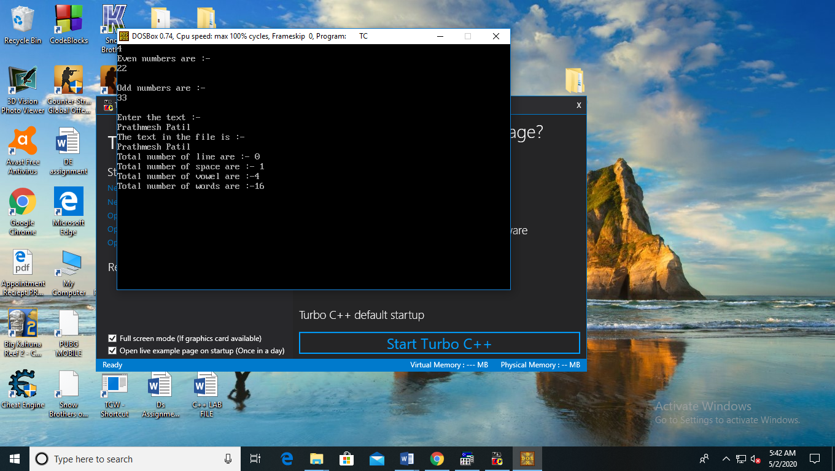

**PRACTICAL NO 28**

Write a program using file handling to accept number from command line

Code :-

#include<stdio.h>

#include<iostream.h>

#include<conio.h>

#include<fstream.h>

#include<string.h>

#include<stdlib.h>

void main(int argc, char *argv[])

{

clrscr();

int ch,oddc=0,evenc=0;

char d;

cout<<argc;

cout<<endl;

ofstream odd("odd.txt");

ofstream even("even.txt");

for(int i=2;i<argc;i++)

{

ch=atoi(argv[i]);

if(ch%2==0)

{

even<<ch;

even<<endl;

evenc++;

}

else

{

odd<<ch;

odd<<endl;

oddc++;

}

}

odd.close();

even.close();

ifstream odd1("odd.txt");

ifstream even1("even.txt");

cout<<"Even numbers are :- "<<endl;

for(i=0;i<evenc;i++)

{

even1>>ch;

cout<<ch<<endl;

}

cout<<endl;

cout<<"Odd numbers are :- "<<endl;

for(i=0;i<oddc;i++)

{

odd1>>ch;

cout<<ch<<endl;

}

even1.close();

odd1.close();

getch();

}

Output :-

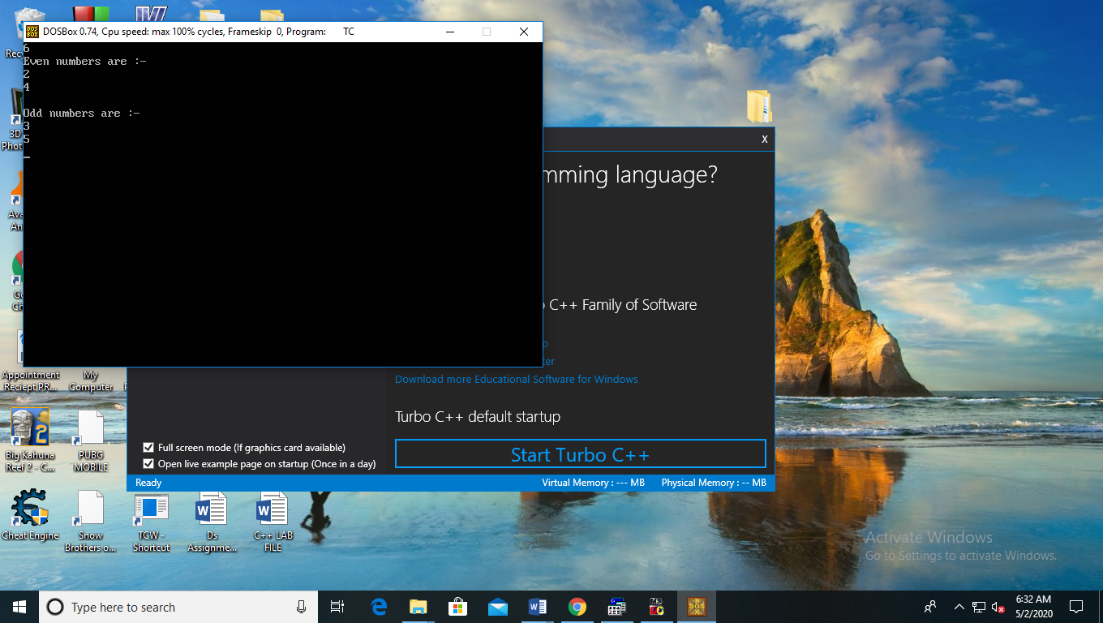

**PRACTICAL NO 29**

Write a program using file handling to swap contents of file

Code :-

#include<iostream.h>

#include<conio.h>

#include<stdio.h>

#include<string.h>

#include<stdlib.h>

#include<fstream.h>

void main()

{

clrscr();

char str,str1[50],str2[50];

fstream output ("one.txt",ios::out);

fstream input("two.txt",ios::out);

cout<<"Enter the content in first file:";

gets(str1);

output<<str1;

cout<<"Enter the content in second file:";

gets(str2);

input<<str2;

output.close();

input.close();

fstream third("temp.txt",ios::in);

ifstream output1("one.txt",ios::out);

while(output1)

{

output1.get(str);

third.put(str);

}

output1.close();

third.close();

fstream input1("two.txt",ios::out);

fstream output2("one.txt",ios::in);

while(input1)

{

input1.get(str);

output2.put(str);

}

input1.close();

output2.close();

fstream third1("temp.txt",ios::in);

fstream input3("two.txt",ios::out);

while(third1)

{

third1.get(str);

input3.put(str);

}

third1.close();

input3.close();

getch();

}

Output:-

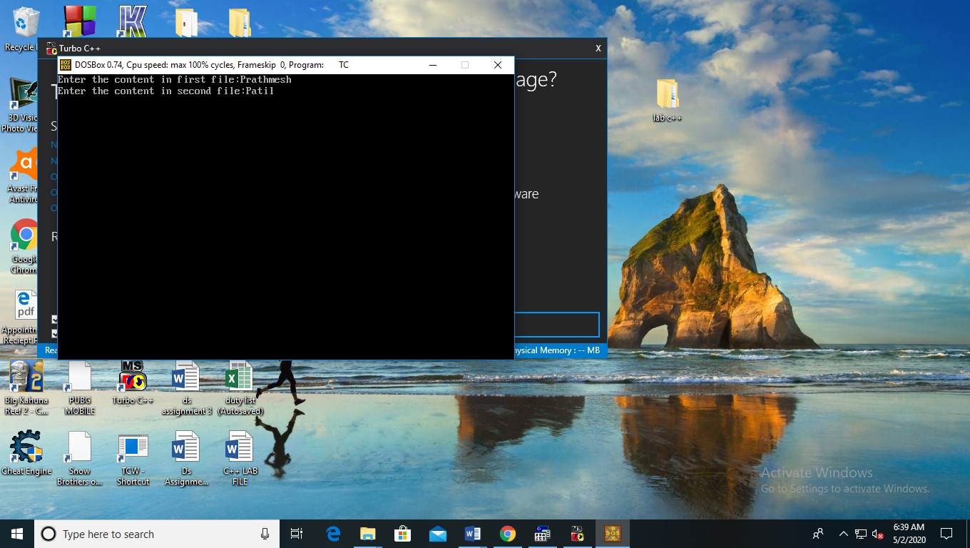

**PRACTICAL NO 30**

Write a program using exception handling so find if a person is senior citizen or not.

Code :-

#include<iostream>

using namespace std;

int main()

{

int age;

cout<<"Enter the age :- ";

cin>>age;

try

{

if(age>=60)

throw(age);

else

cout<<"~~You are not senior citizen~~ \n";

}

catch(int age)

{

cout<<"~~You are senior citizen~~ \n";

}

cout<<"!!!!End of program!!!! \n";

return 0;

}

Output :-

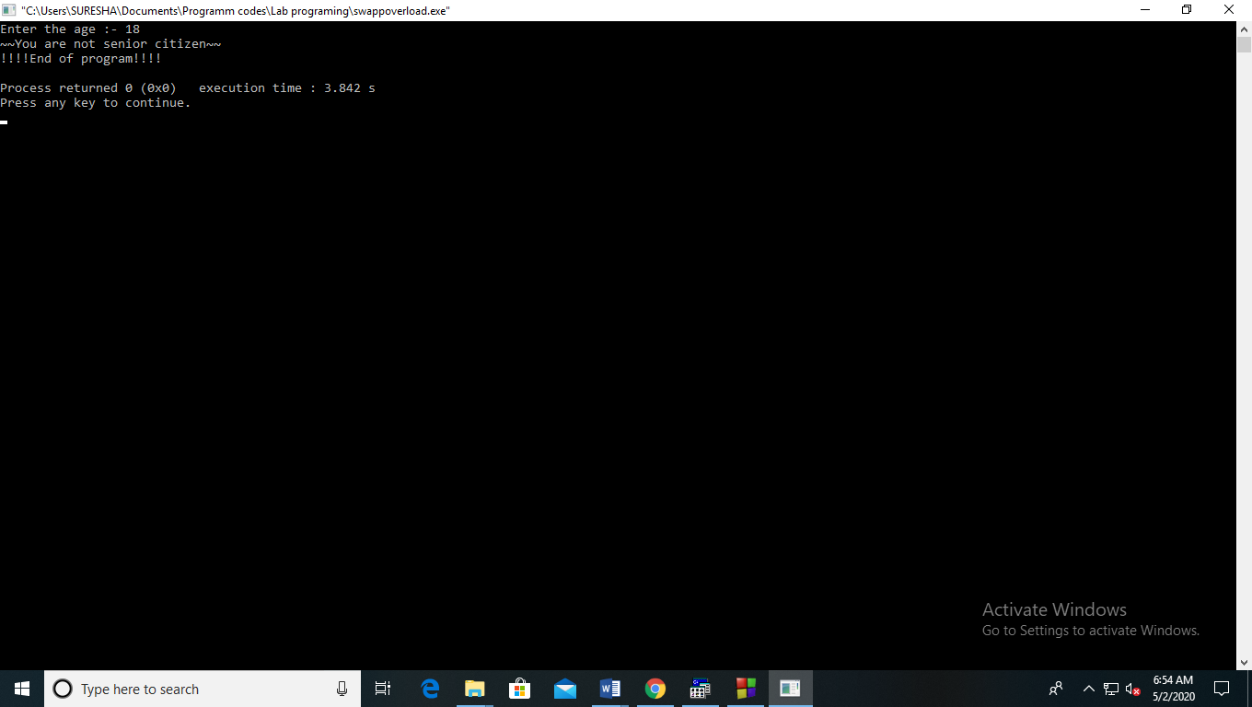

**PRACTICAL NO 31**

Write a program to print rectangle and circle using graphic

Code :-

#include<iostream.h>

#include<conio.h>

#include<stdio.h>

#include<stdlib.h>

#include<graphics.h>

#include<dos.h>

class shape

{

public:

int gd;

int gm;

public:

shape()

{

int gd=DETECT;

initgraph(&gd,&gm,"c:\\tc\\bgi");

}

~shape()

{

closegraph();

}

void draw(int left,int top,int right,int bottom);

void draw(int x,int y,int radius);

void draw(int left,int top,int right,int bottom,int color);

void draw(int x,int y,int radius,char ch);

};

void shape::draw(int left,int top,int right,int bottom)

{

rectangle(left,top,right,bottom);

}

void shape::draw(int x,int y,int radius)

{

circle(x,y,radius);

}

void shape::draw(int x,int y,int radius, char ch)

{

switch(ch)

{

case 'r':

setcolor(5);

break;

case 'b':

setcolor(2);

break;

case 'g':

setcolor(3);

break;

}

circle(x,y,radius);

}

void shape::draw(int left,int top,int right,int bottom,int color)

{

setcolor(color);

rectangle(left,top,right,bottom);

}

void main()

{

shape obj;

obj.draw(10,10,150,150);

obj.draw(50,50,30);

obj.draw(150,150,300,300,4);

obj.draw(60,80,20,'r');

getch();

}

Output :-

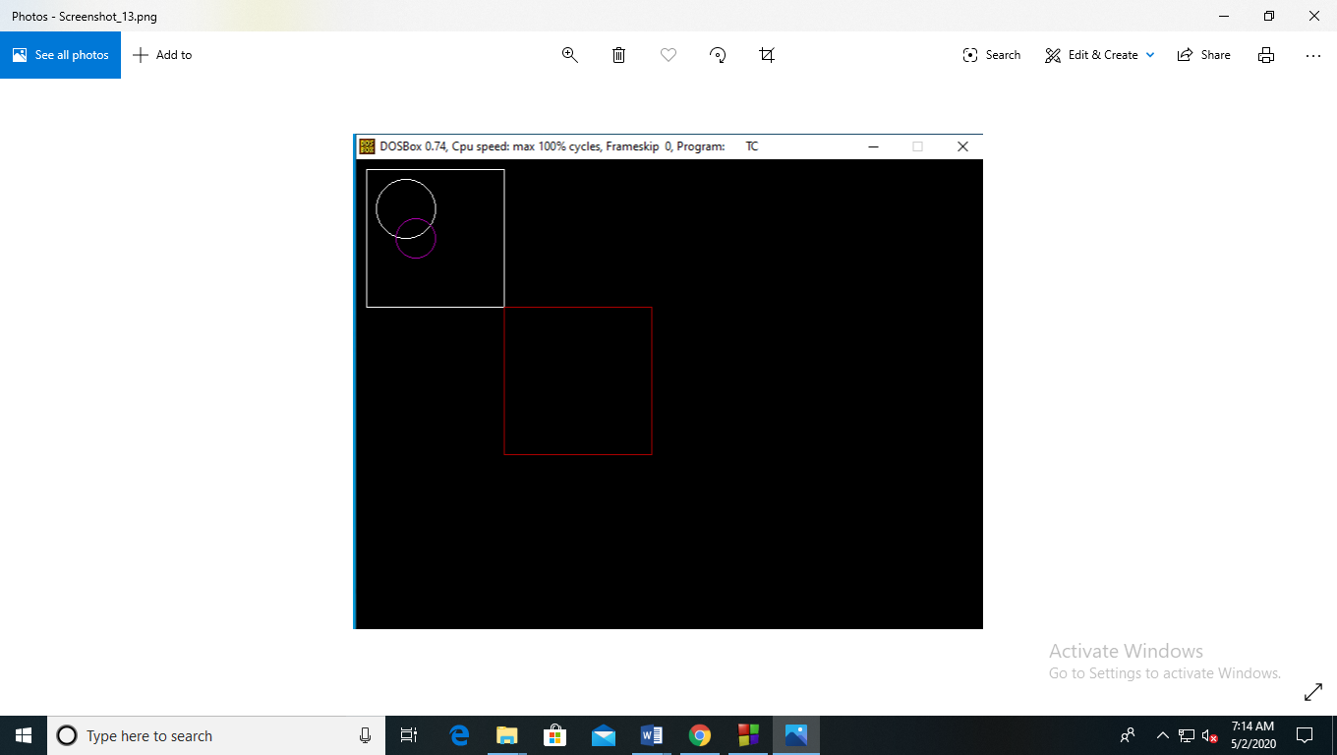

**PRACTICAL NO 32**

Write a program using function overloading to calculate the final balance of the fixed deposit

Code :-

#include<conio.h>

#include<iostream.h>

#include<stdlib.h>

#include<stdio.h>

#include<string.h>

float interest(int principal,int duration)

{

float r=6.5;

float t=(principal*r*duration)/100 ;

return t;

}

float interest(int principal, int duration , char nominee[],char relation[])

{

float r,amt;

if(duration>=5)

{

if((strcmp(nominee," ")!=0) && (strcmp(relation,"wife")!=0) )

{

r=9.5;

amt=(principal*r*duration)/100;

}

else

{

if((strcmp(nominee," ")!=0) && (strcmp(relation,"wife")==0) )

{

r=10.5;

amt=(principal*r*duration)/100;

}

else

{

amt= interest(principal,duration);

}

}

}

return amt;

}

void main()

{

clrscr();

float p,d;

char nominee[30],relation[10];

cout<<"Enter the principal amount "<<endl;

cin>>p;

cout<<"Enter the duration of the fd (in years)"<<endl;

cin>>d;

float amt=interest(p,d);

cout<<"the interest calculated as\n"<<amt;

cout<<endl<<"you have not Entered the nominee details"<<endl;

cout<<"Enter nominee name \n";

gets(nominee);

cout<<"Enter the relation with nominee ";

gets(relation);

amt=interest(p,d,nominee,relation);

cout<<"the interest is nominee registered calculated as :- \n"<<amt;

getch();

}

Output :-

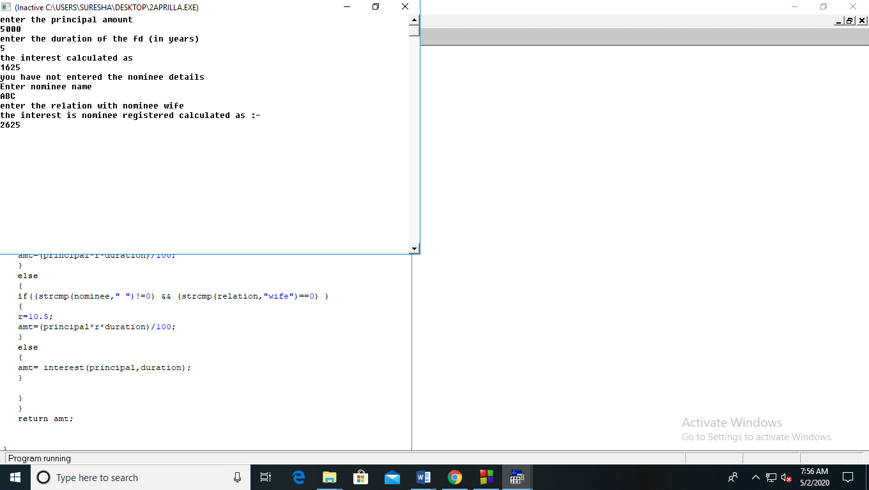

**PRACTICAL NO 33**

Write a program to print

*****

****

***

**

*

For n rows and taking the character from the user

Code :-

#include<iostream>

using namespace std;

int main()

{

int n;

char ch;

cout<<"Enter the number of line :- ";

cin>>n;

cout<<"Enter the caharcter to be printed :- ";

cin>>ch;

for(int j=0;j<n;j++)

{

for(int i=0;i<n-j;i++)

cout<<ch;

cout<<endl;

}

return 0;

}

Output :-

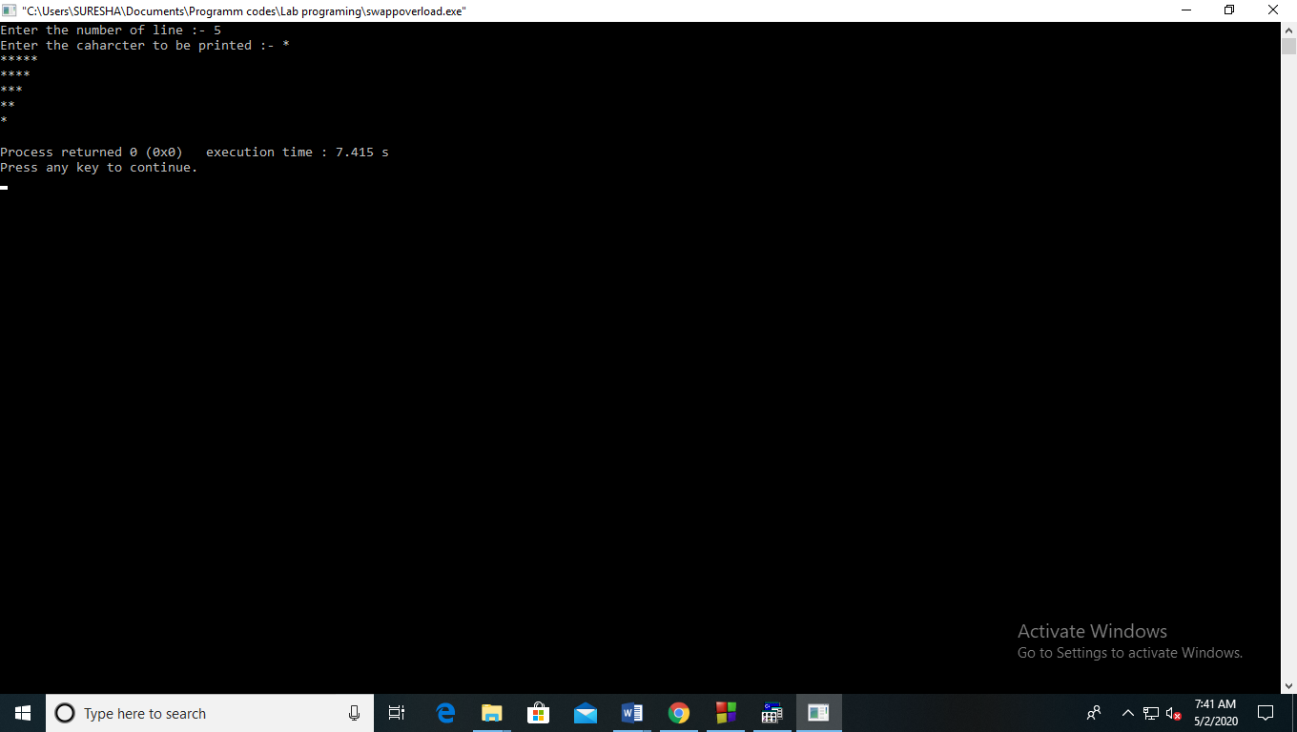

**PRACTICAL NO 34**

Write a program to unary overload - operater.

Code :-

#include<iostream.h>

#include<conio.h>

class A

{

private:

int a;

int b;

int c;

public :

A()

{

a=5;

b=6;

c=7;

}

void operator - ()

{

a=-a;

b=-b;

c=-c;

}

void display()

{

clrscr();

cout<<"a ="<<a;

cout<<endl<<"b ="<<b;

cout<<endl<<"c ="<<c;

}

};

void main()

{

A obj;

cout<<" \n before operator function";

obj.display();

cout<<"\n After operator function ";

-obj;

obj.display();

getch();

}

Output :-

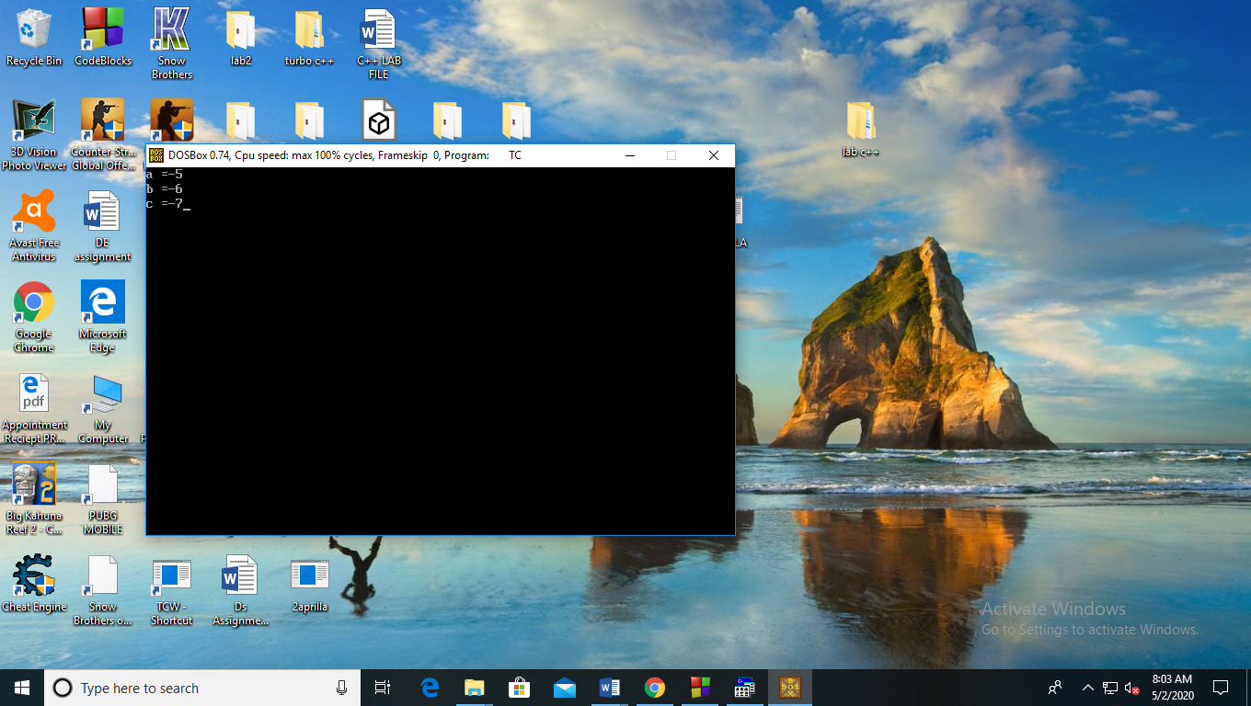

**PRACTICAL NO 35**

Write a program to binary overload + operater for complex number

Code :-

#include<iostream.h>

#include<conio.h>

class complex

{

private:

int a;

int b;

public :

complex()

{

a=5;

b=6;

}

complex operator + (complex obj)

{

complex temp;

temp.a=obj.a+a;

temp.b=obj.b+b;

return temp;

}

void display()

{

clrscr();

cout<<endl<<a<<" + "<< b << " i "<<endl;

}

};

void main()

{

complex obj ,obj1;

obj=obj+obj1;

cout<<"The result :- "<<endl;

obj.display();

getch();

}

Output :-

